Selfish or Selfless? Perceptions of the European Union in Kosovo
By Lucus Hansen
Faculty Mentor: Dr. Stephanie Anderson

Abstract

Why would the European Union (EU) expend the blood and treasure to go to Kosovo to administer justice? Is the EU so selfish and altruistic? No. Although the EU does indeed want Kosovo to have justice, the EULEX mission’s overarching goal, as it is with all CSDP missions, is to “assert the EU’s identity on the world stage” and promote its self-image. Has the message succeeded in Kosovo? The EU has used social media to promote certain narratives about its raison d’etre, specifically promoting the image of the EU as a democratizer, a provider of security who contributes to global peace and well-being around the world. Public opinion polls demonstrate that the message has not been received because of either, inadequate/incompetent use of social media on the EU’s end and, cognitive dissonance caused by scandals. The EU has not lived up to its desired image, thereby causing it to fail at both the micro (local/Kosovo) and macro (Europe/Int’l) levels.

Introduction
The Common Foreign and Security Policy (CFSP) is the organized, agreed foreign policy of the European Union. The question is if member states cannot agree on the sovereignty of the Republic of Kosovo, why do all member states approve it to expend blood and treasure to go to Kosovo to administer justice? The stated objectives of EULEX include building up the rule of law in Kosovo and combatting corruption. However, its list of notable failures, loss of life, and loss of money raises the question of whether or not the European Union is altruistic. While the mission does in fact want to achieve justice, the mission’s overarching goal is to “assert the EU’s identity on the world stage” and promote its self-image. The EU has been using social media as a means to help individual narratives on the mission’s raison d’etre, specifically, advancing the image of the EU as a democratizer and a provider of security who contributes to global peace and well-being around the world. The research question is as follows, has the EU been successful in sending and having their message received by the local population? Public opinion polls show that the EU has not succeeded in having their message received due to either, inadequate/incompetent use of social media on the EU’s end and, cognitive dissonance caused by scandals. Favorability ratings towards EULEX have decreased while ongoing protests, anti-EULEX billboards, and counter-EULEX campaigns have been present. By characterizing EULEX’s goals, techniques, and limitations, the paper also offers implications for the possible future rule of law missions in countries such as Libya, Syria, and Afghanistan. For example, EULEX sought to promote individual narratives to Kosovars that legitimized the existence of the mission. Instead, if future missions included grassroots organizing in addition to social media campaigns, potential for more positive influence exists. Winning the hearts and minds of local populations will continue to be an important aspect of European Union missions, therefore, learning why the current EULEX mission has failed to reach locals is essential for mission success moving forward.
The paper proceeds in six parts. I first briefly outline why narratives are important and which stories the EU is promoting. Secondly, I discuss these narratives, as they exist within Kosovo and Kosovo’s social media platforms. Thirdly, EULEX’s YouTube channel is dissected to show the various social media campaigns existing and the lack of attention given to these campaigns. Fourth, after an establishment of the narratives within Kosovo, public opinion polls are analyzed along with discussion regarding ongoing protests, billboards, and counter-EULEX campaigns. A fifth section speculates on why the EU’s message has not managed to reach Kosovars and finally concludes with offers of policy implications. It details how EULEX may hurt the EU’s credibility and affect its ability to garner support for future missions.
European Union Narratives
The EU has used narratives that focus on the positive roles the EU can assume in the international system. Discourses about the foreign policy and external relations of the EU have had a functional effect, in that they contribute progress to EU integration in situations where internal development seems on hold. To restate, narratives regarding the potential that the EU possess on the foreign state have frequently given new meaning and power to the European project in times of ‘crisis’ or deep Euroscepticism. The article looks at the way in which EU narratives exist in Kosovo and whether or not they have an effect as evidenced by public opinion polls and protests. The rationale draws on the vast discrepancy found between the goals set out in EU narratives and the poor popular support for the European Union Rule of Law Mission in Kosovo. Four narratives follow: EU is a provider of peace and security, EU is a democratizer, EU is a spreader of “good” norms, and the EU as an entity contributes to the well-being of people around the world.
Narratives in the EU’s Common Security & Defense Policy Missions
The EU is a provider of peace and security. At the heart of the European project is its core objective of ensuring peace and security on the European continent. As we understand the founding idea of the European Union or a United Europe, we must understand the background that was a war-ridden European continent. The famous 1950 Schuman declaration laid the basis for plans of European intergovernmental and supranational cooperation. It is the idea that political development depends heavily on the assurance of security, as conflicts or criminality tends to hamper sustainable economic growth, which in turn slows the spread of democracy. The aim of peace shows in both the EU’s internal policy of deepening ties between member states and in its external policy regarding expansion and Europe’s neighborhood. Creating better links between the European Member States has resulted in the ever-closer European Union. Development has steadily increased the area of peace, stability, democracy, and prosperity that the European Union now constitutes. When Olli Rehn was commission in 2009, he stated, “We can pursue deepening and widening in parallel. This has been and remains the best recipe to build a robust and united Europe.” Expansion and Enlargement may be the most successful foreign policy of the European Union, due to its transformative power and effect of democracy, peace, and stability in accession countries.
The 2003 European Security Strategy ‘A secure Europe in a better world’ identified five key threats, which were terrorism, the proliferations of weapons of mass destruction, regional conflicts, state future and organized crime. According to the document, each of these challenges, due to their diverse nature require a mixture of instruments, strategies, and mechanisms. More recently, however, the combination of addressing challenges has fallen short when adequately responding to ongoing crises, repeatedly. The United States ‘pivot’ to Asia announcing in 2012 has forced the European Union to reconsider its role in securing peace and stability in Europe. The primary determinants of the EU’s role in peace and security are identified as its capacity to undertake missions, its willingness to devote resources to security purposes, and its acceptance of the EU as a leading actor in peace and safety. The EU has to make efforts in all these areas – to increase its capacity, its willingness to act, and accept its role as a security provider. The EU is making these attempts in Kosovo with EULEX.
The EU is a democratizer. Promoting democracy has become the central point for numerous states, international organizations, and international non-governmental organizations. Among these international actors interested in democratization, the European Union has come to take a leading role. The EU itself is composed of fifteen democratic states, and in recent years, it has made numerous efforts to change itself from primarily a trading block into a major international actor in the political arena. Within these variations in the EU’s foreign policy has been a focus on democratization. The emphasis shows in the European Council declarations dating from 1991, Association and Partnership and Cooperation Agreements with former communist states, the Maastricht Treaty, previous Lomé Conventions, and in the 1993 Copenhagen Criteria establishing common requirements for EU membership. Not only has the EU been interested in promoting democracy in former communist states, but a focus has also been on the safeguard of democracy in countries that have had limited experience with liberal, participatory political systems. The EU can act as a “powerful catalyst” for change by providing “an elaborate structure of economic and social incentives” so that the strategies of political elites are “strongly shaped by the pressure of externally designed rules and structures.” The EU’s focus on being a democratizer is so much more than just pushing for elections but includes changes to social and economic structures that in turn will drive political elites to move towards a more open type of government.
The EU strategy towards democracy has two important aspects: communication and multilevel governance. According to the White Paper on a European Communication Policy, democracy without building a communicative link towards citizens will not work. Required is promoting three broad principles: inclusiveness- political language should be open to all aspects of society; communication practices should be diverse and address and take into account equally all the different views expressed in public discourse; finally, citizens should have the opportunity to share their views and participate in political practices and the political process.
The EU is a spreader of ‘good’ norms. The European Neighborhood Policy (ENP) recalls liberty, democracy, respect for human rights, and fundamental freedoms as values the EU shares with its neighbors. The general framework of the ENP aimed at achieving long-term common goals state, respect for neighbor’s needs, in short to medium term, and is the most practical way to achieve bilateral cooperation. Officially, the ENP builds on the assumption that states from the EU’s neighborhood have to comply to or make good use of the help the EU provides. Cooperation between the EU and its neighbor countries increases only if the latter adapt to the Union’s requirements and incorporate its advice. The ENP is a tool for the EU to spread its attitudes and values and turn them into norms.
The narrative that portrays the EU has a good neighbor and spreader of standards comes from the belief that the US should build or is striving to make a partnership with its neighbors, through which it could spread a series of universal norms and values. The success of the EU in its region is paramount for proving the ability of the EU to act in a normative or civilian manner on a global scale. External sources of legitimacy are required for the EU to advance its set of normative narratives. The EU aims to export the EU model of political and economic development based on economic liberalization and the rules of the free market, democratic norms and practices, and human rights protection. Democratic principles, minority rights, equal opportunities are all values and principles the EU aims to share with other countries through international action. In official documents, the EU makes use of the “declaratory measures” to export EU norms, values, and principles. The approach to EU international relations is only successfully if the partners receive attractive incentives to comply with EU norms and values, considering that they have to accept EU standards with unilateral adoption instead of negotiation. In Kosovo, the incentive is possible enlargement and inclusion of Kosovo within the European Union.
The EU as an entity contributes to the well-being of people around the world. The European Union has made it a point to tackling the consequences of natural or human-made disasters, which can result in ‘loss of human lives and property, including cultural heritage, the destruction of economic and social infrastructure and damage to the environment. Even more so, the EU has developed many different avenues of support to countries in need through its development aid program. EU development aid goes to nearly 150 countries in the world ranging from Afghanistan to Zimbabwe. Starting in 2014, the EU created a process called ‘graduation’ where EU direct aid to large countries such as India or Malaysia were phased out and transitioned to poorer places around the globe. In the period 2014-2020, about 75% of EU support will go to these countries, which, also, often hit hard by natural disasters or conflict. In addition, the EU claims it has helped the lives of millions through the Millennium Development Goals. These goals ranged from halving extreme poverty, stopping the spread of HID/AIDS, and giving primary education to all children. The EU claims that over the last decade, almost 14 million pupils received the ability to go to primary school, more than 70 million people linked to improved drinking water, and over 7.5 million births attended by skilled heath workers.
According to a Eurobarometer survey among 28,000 EU citizens, 85% of Europeans believe that it is important to help people in developing countries. Tackling poverty in these countries should be a top priority for the EU. The narrative that the EU contributes to global well-being is rooted in EU development cooperation. The EU has touted its transparency, along with its generous aid donations as evidence of their support for helping people all over the world. The European Union states that it in 2013 they provided more than half of public aid or “official development assistance” as defined by the Organization for Economic Cooperation and Development. As of 2013, the EU spent a total of €56.5 billion in 2013 on helping countries across the world in their fight against poverty.
The EU, Kosovo, and Social Media
Roughly, two weeks before Kosovo’s controversial unilateral secession from Serbia in 2008, the European Union adopted a Joint Action creating the European Union Rule of Law Mission in Kosovo, otherwise known as EULEX. EULEX is the largest civilian mission ever launched under the Common Security and Defense Policy (CSDP). The European Union External Action CSDP factsheet for EULEX lays out the mandate and objectives, mission achievements, next steps, and background. The objective of the mission is to assist and support Kosovo authorities and institutions in the rule of law area, specifically in the judiciary, police, and customs areas. An essential aspect of the mission is the joint effort with local authorities, in line with the local ownership principle. EULEX retains administrative responsibility in particular areas such as organized crime, war crimes, and high-level corruptions, along with property and privatization cases. As EULEX is a civilian mission, the mission consists mainly of judges, prosecutors, police officers, and customs officials. The mission is a part of a larger effort undertake by the EU to promote stability and peace in the region while also supporting Kosovo authorities in making reforms that are in line with what the EU calls ‘overall European perspective.'
The European Union and Euro-optimists claim that the EULEX can be successful. However, euro-skeptics contend that Kosovo’s history, lacking infrastructure, and organized crime all render EULEX as highly unlikely to succeed. Balkan journalist Misha Glenny concluded, “The EU will now be lumbered with responsibility for a chronically dysfunctional state for many years to come.” Key official documents relating to Justice and Home Affairs, such as the 2004 Hague Programme and the 2010 Stockholm Programme indicate the EU’s ambitions to further develop its role as a comprehensive security provider and credible international security actor. Kosovo's subjection to a long and structured EU presence, which was significant in creating a path towards EULEX. Vjosa Musliu states that Kosovo has the look of being an EU ‘international project’ with the EU being their greatest donor per capita in the world. In addition to the dependence on EU aid, the dependence of Kosovo on the EU is enhanced by the peculiar sovereignty consolidation. While the legal aspects of EULEX have received some scholarly attention, much less attention exists regarding the narrative the European Union is supplying. Furthermore, even less attention is to how non-EU citizens react to the EU story.
European Union Information Campaigns within Kosovo
The EU internet handbook discusses purposes of campaign communication, which are, informing citizens, sharing experiences, promoting policies or campaigns and, engaging with stakeholders. Communication enacted on behalf of the Commission works through the group of staff members called the Social Media Network (SMN). While social media has a substantial scope for interaction and engagement with groups on EU-related themes and activities, each public campaign takes into account specific policy, its context, what the target audience should be, and the available resources. The strategies listed on the EU’s Internet Handbook page from the European Commission match up with the public outreach campaigns in Kosovo.
The EULEX Kosovo YouTube channel has created 13 ‘playlists’ which groups various videos into specific strategies and goals. Within these thirteen playlists is four “Public Outreach Campaigns.” The focus will be on these playlists due to the emphasis on narrative and public engagement. Below is a breakdown of all created playlists within the EULEX Kosovo YouTube channel. Some playlists have descriptions of what are called “public outreach campaigns” while other playlists do not. The first campaign on the channel is the ‘EULEX on the North” campaign which describes EULEX’s work in the northern region of Kosovo. The information provided will include the playlist title name, how many videos are in each playlist or public outreach campaign, how many playlist views each campaign has, and when the outreach campaign playlist was last updated. Playlist views are different than individual views as they consist of how many times someone has played through the entire playlist rather than just watch one individual video. If there was a video description provided, it will be included next to the corresponding video. Each individual video will include how many views, the likes, dislikes, and if there are any comments.
EULEX On the North Campaign
Official statement: “EULEX has launched an awareness raising campaign about some of its work in the northern region of Kosovo. The campaign is part of an overall series of campaigns to raise awareness about EULEX's work and mandate in Kosovo. In the autumn a campaign focused on EULEX's work in support of the Kosovo rule of law institutions. From December 2012 to January 2013, another campaign focused on EULEX's executive work. This campaign shows EULEX's work to gradually restore the rule of law throughout the north of Kosovo.”
EULEX Kosovo – 11 Videos – 204 Playlist Views – Last updated on Feb 3, 2015
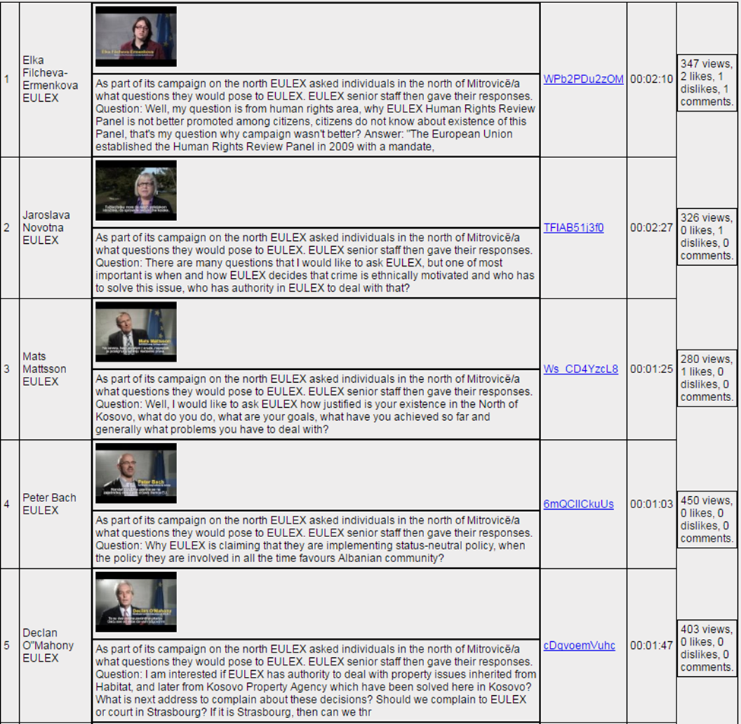

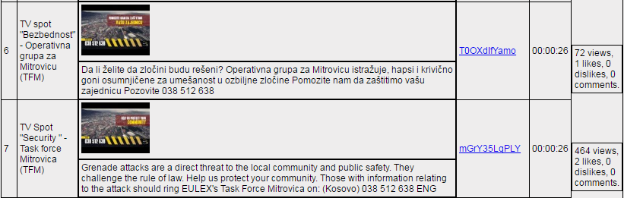
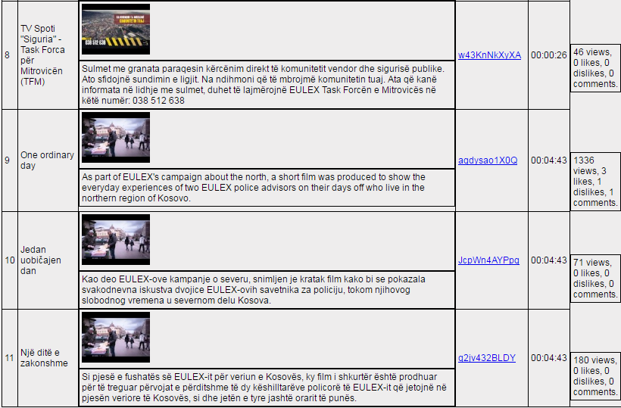
People’ Campaign
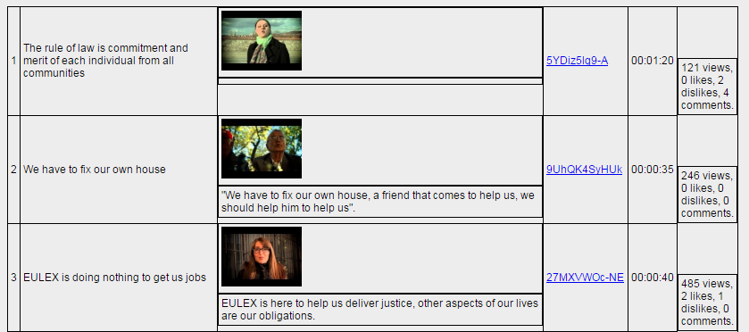
EULEX Kosovo ~ 6 videos ~ 63 playlist views total ~ Last updated on Feb 3, 2015

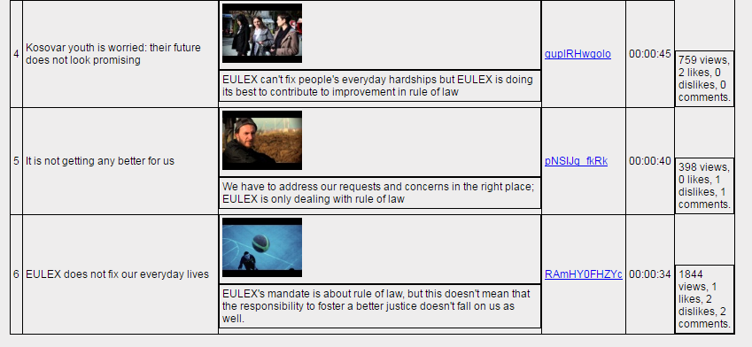

Integration | Justice | Police | Customs
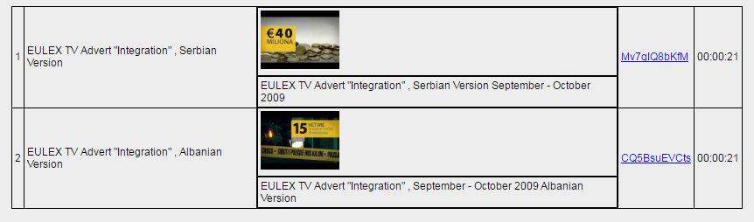
EULEX Kosovo ~ 2 videos ~41 Playlist views ~ Last updated on Feb 3, 2015

Executive Campaign
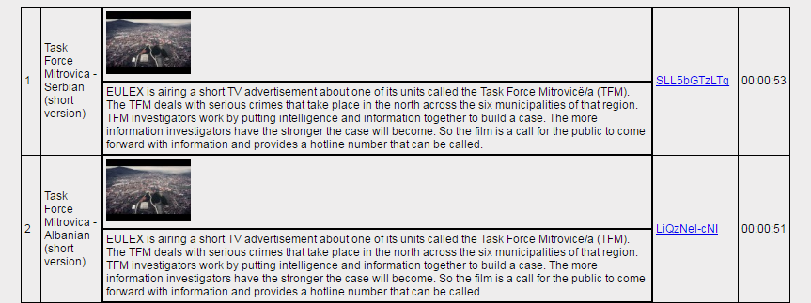
EULEX Kosovo ~ 10 videos ~ 112 Playlist views ~ Last Updated Feb 3, 2015

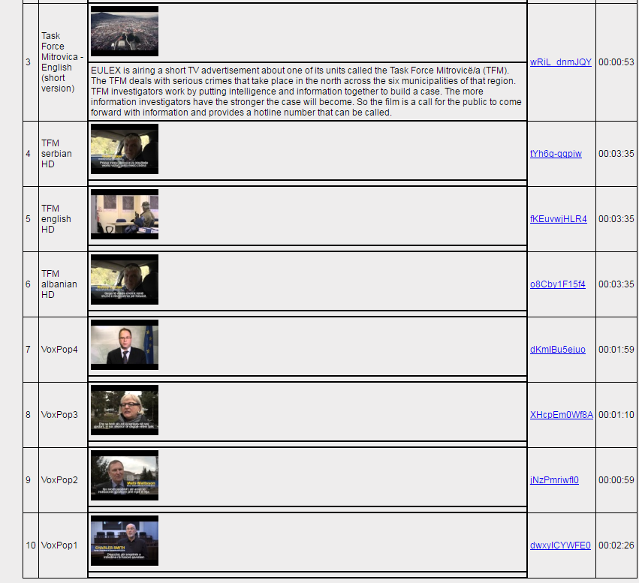

Kosovo Analytics EULEX
The EULEX Kosovo YouTube page consists of 137 videos with a total of 42,304 channel views, and 196 subscribers. The playlist view shows the video with the highest amount of views is titled, “EULEX Kosovo: Police, Justice, Customs”. The count is 2649 views, 3 likes, 5 dislikes, and 0 comments. Other videos that had views over 1,000 were, “EULEX does not fix our everyday lives” with a count of 1844 views, 1 likes, 2 dislikes, and 2 comments, “ELUEX staff dies after incident near Zvecan” with a count of 1864 views, 1 likes, 1 dislike, and 2 comments, and “Justice in One Minute” with a count of 2087 views, 1 like, 0 dislike, and 0 comments. As shown, the amount of views for videos on EULEX Kosovo’s channel are extremely limited with an average of 308.7 views per video. Below is a visual breakdown of the data and it can be concluded that the public outreach campaigns and individual videos put out by EULEX are not reaching many people.
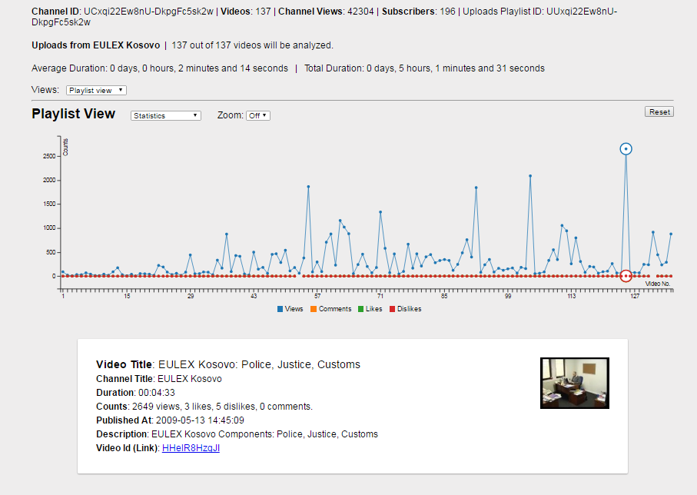

What is the response to the EU’s Message?
The response to the EU’s message is apathetic and or negative. The lack of views to public outreach campaign videos shows that the local population is not watching, or when they are, they are disliking content and showing dissatisfaction with what they are seeing. An important factor when looking at the amount of views for the videos is the numbers regarding the Kosovo population and internet usage. Kosovars are series Internet users with 86.7% using the internet on a daily basis. In comparison, Eurostat states that 84% of European citizens use the internet on a daily basis. It is important to note that Kosovo has a much younger population compared to EU countries and internet has a higher appeal to younger generations.
Based on Census data, in average, almost six family members are living in the same household in Kosovo. Compared to other statistics, it turns out that on average at least half of household members are internet users. Most of the young internet users use the English language as a primary language, while age groups 40-59 use the Albanian language more. Female users use Albanian and English more than male counterparts do.
Information regarding internet usage and language preference conclude that Kosovo has high internet user and household penetration rates comparable to other developed countries. The situation in Kosovo is very similar to other developed countries in that internet has been traditionally used mostly for entertainment and socializing. There are many other services that internet provides but the focus here is YouTube. Research shown gives the impression that YouTube and the internet would be an effective medium when it comes to reaching the younger generation in Kosovo. While most of the youth use the internet and are a part of YouTube, the EULEX Kosovo channel has not had any substantial growth in views, likes, comments, or subscribers. Social media is not the problem due to the proven attention given to other channels located within Kosovo. Gold AG is a Kosovo musician who produces music in English and Albanian. On the next page is an analytical breakdown of Gold AG’s YouTube page. The channel consists of 309 videos, 131.49 million views, and 128,545 subscribers. Clearly, social media is not the problem when assessing the adverse response to the EU’s message.
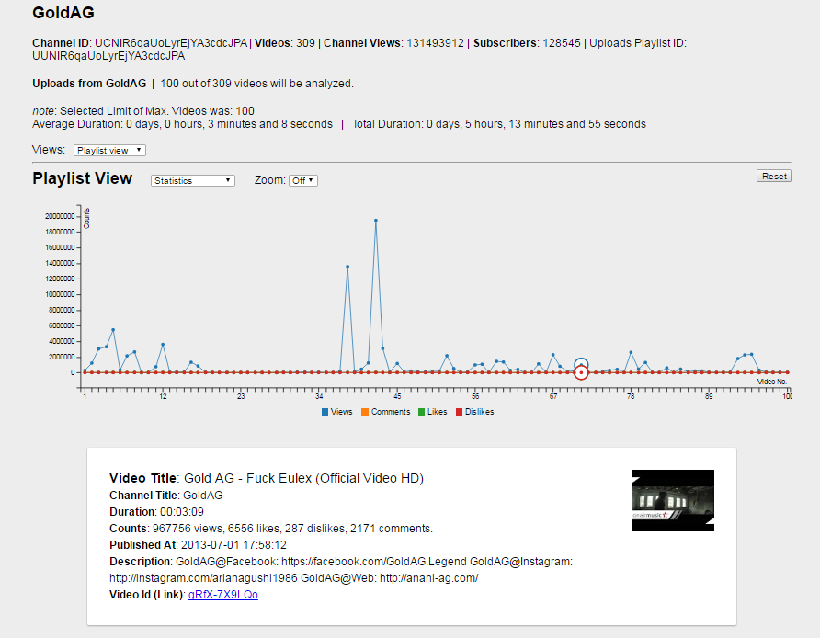

Public Opinion Polls
The Kosovo Security Barometer (KSB) is a particular program of the Kosovar Center for Security Studies (KCSS) designed to serve as an annual publication. The primary focus of the KSB is to measure public opinion perceptions towards security institutions. KCSS has no political constraints in communicating the findings and messages. In the path of becoming a functioning democracy, it is critical that local populations put forth confidence in national institutions and that these establishments win the trust of the citizens. The Kosovo Security Barometer aims to surface perceptions of trust towards the judicial, legislative, and executive branches.
Respondents expressed little confidence and doubts towards Kosovo judiciary. Almost 60% said that had no trust or little faith in the judicial system. Eight percent is where the satisfaction rate stands for the Kosovo courts with another 36% reporting that they were somehow satisfied. Half of those interviewed said that they were very dissatisfied with the work of the Kosovo courts. When asked for a reason as to why they were so dissatisfied, 36% stated that Kosovo courts worked too slowly, followed by a lack of trust in the judicial system (28%), and a lack of information (12%). The rest split between the availability of alternative means of resolving their issues, distance from home, and something else. Respondents responded if they agreed or disagreed with the statement, “Courts are independent.” Only 14% said they agreed.

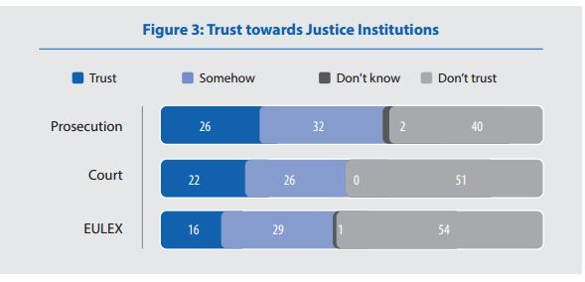
2015
While citizens were also very critical towards national justice institutions, EULEX consistently has polled at lower trust levels than Kosovo Courts or Kosovo Prosecution. More than 51 percent declared they do not trust Kosovo Courts. Forty Percent stated that they do not believe Kosovo Prosecution. Fifty-four percent do not trust EULEX, only 16 percent trust.

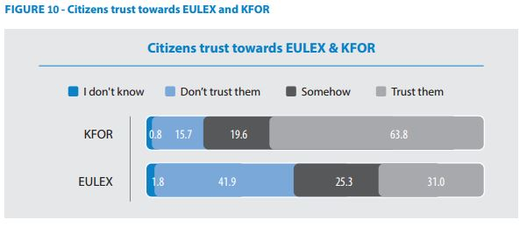

2014
EULEX trust has remained flat with 41.9 percent of the respondents stating that they do not trust the mission. “This high level of distrust is mainly related to the perception on the limited contribution of this mission in supporting the Kosovo institutions in preventing and combating corruption and organized crime.”
Do you consider EULEX/KFOR fair and unbiased?
A survey by the Kosovo Security Barometer asked respondents to agree or disagree with the following statement, ‘EULEX/KFOR are equitable and impartial. The vast majority agreed in the case of KFOR but had an opposite opinion of EULEX.
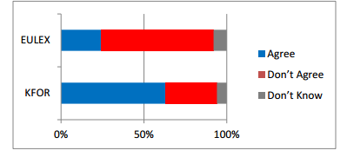

The distrust in Kosovo judicial systems and EULEX shows there is a direct need to combat negative sentiment in the country. EULEX has filled the need in their social media campaigns and other ventures designed to combat anti-EULEX feelings. The public outreach campaigns echo European Union narratives also aimed at EU citizens.

Billboards, Graffiti, and Demonstrations
Kosovo Liberation Army organizations have placed billboards throughout Kosovo with the inscription: “EULEX is doing nothing to fight War Crimes.” KLA fighters and war veterans’ associations have harshly criticized EULEX and asked the authorities in Pristina to review its mandate. The War Veterans Association in different parts of Pristina put up several billboard posters criticizing EULEX. The billboards are just one part of an ongoing campaign against EULEX and its operations. Other graffiti and tags exist sprawled across the city with phrases such as, ‘EULEX Go Home”, “EULEX Made in Serbia,” and “EULEKSPERIMENT.”
People have conducted numerous protests in Kosovo, some turning violent while others have been without incident. Twenty Kosovo Albanian NGO’s organized protests along with the Self-Determination movement, with the support of Kosovo’s independent unions. Self-Determination leader Albin Kurti said that the neutral status of the EU mission “essentially means that it does not recognize Kosovo independence and that the process of confirming its status remains open.” The protestors called on UNMIK and EULEX to leave Kosovo immediately. Kosovo police, KPS, and officials were only in front of the EULEX headquarters in Priština, even though protesters walked through the entire city.
In 2009, the hardline nationalist Vetevendosje Self-Determination movement launched fresh protests against EULEX. The group overturned 28 EULEX cars during a demonstration and demanded that a controversial policing policy with Serbia cease to exist. Nearly 20 organizations apart of the self-determination movement participated. Demonstrators in Kosovo have fought running battles with police. In January of 2016, protesters set fire to the government’s headquarters as groups angered over an accord with Serbia. The protesters were against the European Union-brokered deal to give Kosovo’s ethnic Serb minority greater local government powers and the possibility of financing from Belgrade. Opposition leaders say the government should resign over the accord and call an early election.
Why has the EU’s message not been successful?
The EU’s Communications protocol needs to be overhauled to improve its diffusion (i.e. spread of EU’s message). However, even so, the cognitive dissonance (the fact that it says one thing, but does the opposite) between the message and the reality must be addressed. Many different factors contribute to the problem of people not being receptive to the EU’s message. First, the structural defects of EULEX. A visibly irrational allocation of resources, poor internal accountability, external oversight, and weak judicial independence. In 2015, the EU published an independent report regarding EULEX. The report pointed to several weaknesses in the management of the mission and included a scandal involving an official of the mission accused of having covered up a case of judicial corruption within its ranks.
The EU report is an important piece when looking at why the EU’s message has not been successful in Kosovo. The report contradicts the false narrative of the “success story” and sheds some light on Kosovo’s real problems. A shift in policy and structure could help benefit the EU, EULEX, and their credibility as it relates to CSDP missions. EULEX was meant to prove the possibility of an active foreign policy from the EU, however, from the start, it faced credibility problems has the EU itself is divided on Kosovo’s independence as five member states do not recognize Kosovo’s independence. Andrea Capussela states that,
EULEX has become a symbol of incompetence, not of European values, and a costly veil that hides the shenanigans of the elite from the eyes of Kosovo’s citizens. The EU should audit and reform EULEX, replace its senior management and give the mission the guidance and political support it needs to perform its mandate.
Clearly, the message the EU is supplying is not consistent with how the local population feels, and the structural issues of the mission must not be dismissed when judging why people are not paying attention to their outreach campaigns.
Scandals also play a role in affecting why there has been such negativity towards the mission. Transparency International, a leading NGO, has accused EU law chiefs in Kosovo of “intimidation” of potential whistleblowers. In 2009, Azem Syla, a political heavyweight close to Kosovo’s prime minister, was identified by a whistleblower as responsible for several murders. EULEX is still investigating. By contrast, it has just indicted Oliver Ivanovic, a Kosovo Serb and leading force for ethnic reconciliation in the north, for war crimes. Ms. Mogherini should instruct her envoy to not just look at the latest scandal, but also rather look into EULEX as a whole.
Maria Bamieh, a former prosecutor for EULEX, accused her former employer of unfair dismissal after she raised concerns over corruption within the ranks. In October of 2014, Kosovo daily Koha Ditore published articles showing that Bamieh’s reports on high-level corruption within EULEX were ignored. Bamieh was subsequently stripped of her position. According to documents, Bamieh wrote a letter to the heads of EULEX complaining over wiretaps of the former Minister of Health Ilir Tolaj, on trial for bribery and tax evasion. On the wiretaps, Tolaj speaks about attempts to negotiate a lesser sentence from Judge Francesco Florit. Family members of other defendants also stated that Florit received 300,000 euros from another suspect. The ongoing scandals do not help the EU and its favorability and trust ratings in Kosovo.

Conclusion
The European Union narratives are not persuasive in Kosovo as evidenced by the lack of attention given to the EULEX Kosovo public outreach campaigns, Kosovo public opinion polls, ongoing demonstrations, protests, and billboards. One aspect is the separation of EULEX officials and the local population. EULEX officials distanced from the public in barbed wire protected buildings while driving expensive EU vehicles do not relate well to ordinary citizens in Kosovo. EU officials also live at a different and visible standard of living. While the separation may not be a huge factor, when complimented by the ongoing investigations over corruption and fraud within EULEX, citizens do not have a favorable trust towards the mission. Clearly, a problem of relatability exists otherwise removing the fences at EULEX headquarters would not be part of the mission’s reconfiguration and new mandate. As of April 24, 2017, EULEX removed fences at the headquarters annex building and opened the facility up for public access. Some EULEX offices will also be re-located to the Main Building as part of a gradual transfer of security competences to local authorities. Part of the mission’s mandate is to help curb corruption; however, scandals have pushed many to believe that EULEX is part of the corruption problem.
From the start of the European Project, there was a tension between the idea of the EU as a future superpower, a large nation-state, its ability to challenge the United States, and the understanding of the EU has a new type of world actor. 1998 saw the CSDP proposed during the Kosovo crisis, created in 2003, and is the domain of EU policy covering civilian emergency management, defense, and military aspects. During the same year, the European Security Strategy (ESS) concluded and was the policy document that guided the European Union’s international security strategy. The ESS provides the conceptual framework for the Common Foreign and Security policy, including what would later become the Common Security and Defense Policy. The strategy report, titled, “A Secure Europe in a Better World,” the ESS is a comprehensive document which analyses and defines for the first time the EU’s security environment, future challenges, and subsequent political implications for the EU.
Numerous problems associated with the EULEX mission have hurt the credibility of the EU. The failures have led some to believe that rule of law mechanisms imported from abroad do not work, especially when they have executive mandates as EULEX has. Since the launch of the common security and defense policy, Europe is experiencing something new with so many different problems and crises along their borders or within their territory. Given the evolution of these crises, the EU and its members have an important duty to act, to provide security and protection, and reduce the instability in today’s environment. The CSDP should be an essential tool available to Europe to take responsibility for its security and that of its neighbors; however, it has failed. EULEX sends a clear message about the current state of the CSDP as well as a warning. One of the most pressing issues is the fact that encouraging policy goals agreed upon during the December 2013 CSDP council meeting have not followed. In the global context, the EU has developed its political ambitions and its political and economic capabilities. As it tries to reaffirm itself as a security player on the world stage of international relations, it has run into problems of credibility mainly due to structural problems in the mission, scandals and corruption within its ranks, and poor EU communication policies. The combination has led to demonstrations, protests, anti-EULEX billboards, and low favorability and trust ratings in Kosovo public opinion polls. EULEX has been a tough experience for the EU. Regardless of the experience, the EU maintains a strong normative and economic power and will still aim to push its narratives to EU citizens along with those hoping for enlargement.

Works Cited

Bickerton, Chris J., Bastien Irondelle, and Anand Menon. "Security Co-operation beyond the Nation-State: The EU's Common Security and Defence Policy." JCMS: Journal of Common Market Studies 49.1 (2010): 1-21. Web.
Bradshaw, T., & Garrahan, M. (2008). “Rival forecast to catch YouTube”. Financial Times. http://us. ft. com/ftgateway/superpage. ft.
Bytyci, Fatos. "Protesters Fight Police, Set Fire to Kosovo Government Headquarters." Reuters. January 09, 2016. Accessed November 20, 2016. http://www.reuters.com/article/us-kosovo-fire-idUSKCN0UN0NR20160109.
Capussela, Andrea. "Eulex Report Exposes EU Failure in Kosovo." EUobserver. N.p., 16 Apr. 2015. Web. 15 Dec. 2016.
Council of the European Union. "Council Joint Action 2008/124/CFSP of 4 February 2008 on the European Union Rule of Law Mission in Kosovo, EULEX KOSOVO." EUR-Lex Access to European Union Law. N.p., 16 Feb. 2008. Web.
Council of the European Union. The Hague Programme: Strengthening Freedom, Security and Justice in the European Union. Rep. no. 16054/04. Council of the European Union. Brussels: n.p., 2004. Print.
Council of the European Union. The Stockholm Programme: An Open and Secure Europe Serving and Protecting Citizens. Rep. no. 115/1. Council of the European Union. N.p.: n.p., 2010. Print.
Council Joint Action 2008/124/CFSP of 4 February 2008 on the European Union Rule of Law Mission in Kosovo, EULEX Kosovo
EU-Graps, The EU as Global–Regional Actor in Security and Peace, 2012
European Commission Eurobarometer Special Surveys. N.p., n.d. Web. 15 Dec. 2016. http://ec.europa.eu/public_opinion/archives/eb_special_439_420_en.htm#421
European Commission. Press Release Database. Five years of an Enlarged EU. European Commission. N.p., 28 Apr. 2009. Web. 15 Dec. 2016. http://europa.eu/rapid/press-release_SPEECH-09-205_en.htm
European Union External Action. "EULEX Commemorates the Anniversary of the Death of Customs Officer." EULEX Commemorates the Anniversary of the Death of Customs Officer - News - EULEX, Kosovo, European Union Rule of Law Mission in Kosovo, EU, European Union, European Union External Action. September 19, 2014. Accessed December 15, 2016. http://www.eulex-kosovo.eu/?page=2,11,475.

European Union External Action. "EULEX Kosovo EU Rule of Law Mission in Kosovo." European Union External Action. October 2014. Accessed August 7, 2016. http://www.eeas.europa.eu/archives/csdp/missions-and-operations/eulex-kosovo/pdf/factsheet_eulex_kosovo_en.pdf.
European Union, Treaty on European Union (Consolidated Version), Treaty of Maastricht, 7 February 1992, Official Journal of the European Communities C 325/5; 24 December 2002, Accessed December 15, 2016. http://www.refworld.org/docid/3ae6b39218.html
European Union. "Use of Social Media in EU Communication." The EU Internet Handbook. European Commission, 06 July 2016. Web. 06 Nov. 2016.
"European Year for Development." EU development aid | European Year for Development. N.p., 14 Jan. 2015. Web. 15 Dec. 2016.
Former High Representative for Foreign and Security Policy, Javier Solana in: ‘EU: Solana says membership for Caucasus “A different story”’. Radio Free Europe/Radio Liberty [online], 15 November 2006. Accessed 10 February 2012http://www.rferl.org/content/article/1072738.html
Howorth, J. (2007) Security and Defence Policy in the European Union (Basingstoke: Palgrave).
Internet Penetration and Usage in Kosovo. Rep. Kosovo Association of Information and Communication Technology, Unversum University College. Republic of Kosovo Ministry of Foreign Affairs, Aug. 2013. Web. 15 Dec. 2016.
Kosovar Centre for Security Studies. Kosovo Security Barometer. Rep. 4th ed. N.p.: National Endowment for Democracy, 2014. Print. Kosovar Centre for Security Studies.
Limani, Lura. "Bamieh Wins First Legal Victory over EULEX - Prishtina Insight." Prishtina Insight. N.p., 15 June 2016. Web. 15 Dec. 2016.
Manners, Ian. 2002. Normative power europe: A contradiction in terms? JCMS: Journal of Common Market Studies 40 (2): 235-58.
Musliu, V. (2015). The EU and the balkans: Shifting meanings after the crisis. Politicka Misao, 52(4), 32-42. Retrieved from http://libproxy.uwyo.edu/login/?url=http://search.proquest.com/docview/1798417853?accountid=14793
Nielsen. (2012). State of the media: The social media report. Retrieved April 8, 2014, from http://www.nielsen.com/content/dam/corporate/us/en/reportsdownloads/2012-Reports/The-Social-Media-Report-2012.pdf.
Niţoiu, Cristian. The EU Foreign Policy Analysis: Democratic Legitimacy, Media, and Climate Change. New York City: Palgrave Macmillan, 2015. Print.
Panebianco, Stefania, and Rosa Rossi. "EU attempts to export norms of good governance to the Mediterranean and Western Balkan countries ." Jean Monnet Working Papers in Comparative and International Politics (2004): n. pag. Web. 15 Dec. 2016. http://aei.pitt.edu/6109/1/jmwp53.pdf
Peci, Edona. "EU Prosecutors in Kosovo Vow to ‘Deliver Justice’." Balkan Transitional Justice. June 14, 2013. Accessed November 20, 2016. http://www.balkaninsight.com/en/article/eulex-determined-to-deliver-justice-on-war-crimes.
Pond, Elizabeth, "The EU's Test in Kosovo." The Washington Quarterly 31, no. 4 (2008): 97-112. https://muse.jhu.edu/ (accessed August 7, 2016).

Solana, J. (2007) ‘The Lisbon Treaty: Giving the EU More Coherence and Weight on the International Stage’.
Schimmelfennig, Frank, and Hanno Scholtz. "EU Promotion of Democratic Governance in the Neighbourhood." Democracy Promotion by Functional Cooperation, 2007. doi:10.1057/9781137489357.0010.
"Shaping of a Common Security and Defence Policy - Eeas - European Commission." European Union External Action. European Union, 8 July 2016. Web. 15 Dec. 2016.
Stefan Lehne, Carnegie Europe, A Window of Opportunity to Upgrade EU Foreign Policy, May 2014
Stelzner, Michael. "2015 Social Media Marketing Industry Report : Social Media Examiner." Social Media Examiner. May 26, 2015. Accessed December 15, 2016. http://www.socialmediaexaminer.com/social-media-marketing-Industry-report-2015/.
Whitehead, L., 2001. The enlargement of the European Union: a ‘risky’ form of democracy promotion. In: Whitehead, L. (Ed.), The international dimensions of democratization, expanded ed. Oxford University Press, Oxford, pp. 415e442.

"EULEX commemorates the anniversary of the death of Customs Officer." European Union External Action, 19 September 2016, March 26, 2017. <http://www.eulex-kosovo.eu/?page=2%2C11%2C475> (26 March 2017)
"Treaty on European Union (Consolidated Version), Treaty of Maastricht." Refworld, 7 February 1992, <http://www.refworld.org/docid/3ae6b39218.html> (26 March 2017)
Chris J. Bickerton et al., "Security Co-operation beyond the Nation-State: The EU's Common Security and Defence Policy." JCMS: Journal of Common Market Studies 49.1 (2010): 1-21.
European Commission, “Five years of an Enlarged EU,” Press Release Database, 28 April 2009, <http://europa.eu/rapid/press-release_SPEECH-09-205_en.html> (30 September 2016)
Frank Schimmelfennig and Hanno Scholtz, “EU Democracy Promotion in the European Neighborhood: Conditionality, Economic Development, and Linkage,” European Union Politics 9, no. 2 1 June 2008
European Commission, “European Security Strategy – A Secure Europe in a Better World”, 12 December 2003, <https://europa.eu/globalstrategy/en/european-security-strategy-secure-europe-better-world> (28 March 2017)
Stefan Lehne and Carnegie Europe, “A Window of Opportunity to Upgrade EU Foreign Policy,” 2 May 2014, < http://carnegieeurope.eu/2014/05/02/window-of-opportunity-to-upgrade-eu-foreign-policy-pub-55491> (2 April 2017)
Luk Van Langenhove et al.,” “A more capable Europe is within our grasp”, European Security Strategy, 2003.
Laurence Whitehead . The international dimensions of democratization: Europe and the Americas. (Oxford: Oxford University Press, 2001.)
European Commission, “White paper on a European communication policy”, Press Release Database, 1 February 2006, <http://europa.eu/documents/comm/white_papers/pdf/com2006_35_en.pdf> (30 September 2016)
European Commission, “European neighbourhood policy”. Luxembourg: Office for Official Publications of the European Communities, 2008, < https://ec.europa.eu/europeaid/sites/devco/files/annual-report-2008-highlights-ec-development-external-assistance-policies-implementation-in-2007_en_11.pdf> (30 September 2016)
Stefania Panebianco and Rosa Rossi, "EU attempts to export norms of good governance to the Mediterranean and Western Balkan countries", Jean Monnet Working Papers in Comparative and International Politics 2004. <http://aei.pitt.edu/6109/1/jmwp53.pdf> (30 september 2016)
Javier Solana, “EU: Solana says membership for Caucasus A different story”. Radio Free Europe/Radio Liberty, 15 November 2006. <http://www.rferl.org/content/article/1072738.html> (25 September 2016)
Ian Manners, “Normative power europe: A contradiction in terms?” 2002, JCMS: Journal of Common Market Studies 40 (2): 235-58.
Ian Manners, “Normative power Europe”
"European Year for Development." European Union Report, 14 Jan. 2015, < https://europa.eu/eyd2015/en/content/eu-development-aid > (15 Dec. 2016)
European Commission, “Eurobarometer Special Surveys” n.d., < http://ec.europa.eu/public_opinion/archives/eb_special_en.htm> (15 December 2016)
"European Year for Development." 2015.
European Union External Action, "EULEX Kosovo EU Rule of Law Mission in Kosovo." October 2014, <http://www.eeas.europa.eu/archives/csdp/missions-and-operations/eulex-kosovo/pdf/factsheet_eulex_kosovo_en.pdf> (10 November 2016)
European Union External Action, "EULEX Kosovo EU Rule of Law Mission in Kosovo."
Elizabeth Pond, "The EU's Test in Kosovo." The Washington Quarterly 31, no. 4 2008: 97-112.
Council of the European Union, “The Hague Programme : Strengthening Freedom, Security and Justice in the European Union. Rep. no. 16054/04”, Council of the European Union. Brussels, 2004. Print.
Council of the European Union, “The Stockholm Programme — An Open and Secure Europe Serving and Protecting Citizens. Rep. no. 115/1”, Council of the European Union, 2010. Print.
Vjosa Musliu, “The EU and the balkans: Shifting meanings after the crisis”, Politicka Misao, 52(4), 32-42.2016
European Commision. "Use of Social Media in EU Communication." The EU Internet Handbook , 06 July 2016.
Kosovo Association of Information and Communication Technology, "Internet Penetration and Usage in Kosovo", August 2013 , STIKK, <http://www.mfa-ks.net/repository/docs/STIKK_raport_eng_2013_short_web.pdf> (20 April 2017)
Kosovo Association of Information and Communication Technology, “Internet Penetration and Usage in Kosovo”. 2013
Kosovar Centre for Security Studies, “Kosovo Security Barometer”. National Endowment for Democracy, 2015. Print
Kosovar Centre for Security Studies. “Kosovo Security Barometer”. 2015
Kosovar Centre for Security Studies, “Kosovo Security Barometer” 2014.
Edona Peci, "EU Prosecutors in Kosovo Vow to ‘Deliver Justice’." Balkan Transitional Justice, 14 June 2013, <http://www.balkaninsight.com/en/article/eulex-determined-to-deliver-justice-on-war-crimes> (25 August 2016)
Fatos Bytyci,. "Protesters Fight Police, Set Fire to Kosovo Government Headquarters." Reuters, 09 January 2016, <http://www.reuters.com/article/us-kosovo-fire-idUSKCN0UN0NR20160109> (18 August 2016)
Andrea Capussela. "Eulex Report Exposes EU Failure in Kosovo." EUobserver 16 Apr. 2015. < https://euobserver.com/opinion/128343> (15 Dec. 2016)
Andrea Capussela, "Eulex Report Exposes EU Failure in Kosovo." 2015.
"Small Balkan scandal." The Economist. 15 November 2014. <http://www.economist.com/news/europe/21632598-eus-mission-kosovo-ensnared-corruption-claims-small-balkan-scandal> (16 September 2016)
Lura Limani, "Bamieh Wins First Legal Victory over EULEX" Prishtina Insight, 15 June 2016. < http://prishtinainsight.com/bamieh-wins-first-legal-victory-eulex/> (15 Dec. 2016)
Lura Limani, "Bamieh Wins First Legal Victory over EULEX". 2016
European Commission, "Shaping of a Common Security and Defence Policy,” European Union External Action. European Union, 8 July 2016, < https://eeas.europa.eu/topics/common-security-and-defence-policy-csdp/5388/shaping-of-a-common-security-and-defence-policy-_en> (23 March 2017)

