THE CULTURE OF CLIMATE NEGOTIATIONS
Historical Authors and Contemporary Collective Action in the European Union
By Cathie Jo Martin
Boston University
Presented at the annual meeting of EUSA, May 4-6, 2023, Pittsburgh, PA
Abstract
This paper seeks to understand the historical cultural underpinnings underlying disputes and negotiations over environmental policy within the European Union. Climate change is one of the most urgent problems facing Europe and the world today, and since the 1990s, the European Union has been grappling with ways to restrain the production of greenhouse gases and to make the transition to renewable energy. Yet fundamentally different cultural understandings of policy problems and their solutions may inhibit action at the supranational level. Thus, my project explores countries’ varying ways of responding to EU initiatives, such as the European Green Deal, and their stances in processes of negotiation over environmental policy at the EU level. I then consider whether these cross-national variations correspond to differences in countries’ historical views of nature and the responsibility of humans to conserve the natural world. Following methods developed for my forthcoming book on culture and education policy, Education for All: Literature, Culture and Education Policy in Britain and Denmark, I use computational linguistic techniques to identify word frequencies and topic modeling in national literary corpora that I have constructed for Britain and Denmark. I combine the quantitative analysis with a close reading of literary texts to explore the narratives that authors in the diverse countries construct about the natural world.
INTRODUCTION
Climate change is one of the most urgent problems facing the European Union today, as climate catastrophes ravage the world with increasing intensity. Since the 1990s, the European Union has been grappling with ways to restrain the production of greenhouse gases and to make the transition to renewable energy; yet diverse national preferences for climate policy threaten to derail EU action (Solorio & Jörgens 2020). Some countries such as Denmark have been leaders in the transition to renewable energy sources and advocate for strong government interventions to facilitate profound industrial restructuring. Other countries such as Britain (before it left the EU) have preferred a more limited program of regulating greenhouse gas emissions with market-based policies and eschewed strong government action at both the national and supranational levels (Im et. al. 2023) According to the World Bank, 37.52 percent of all energy consumption comes from renewable energy sources in Denmark; whereas, in the United Kingdom, only 12.24 percent of all energy used comes from renewable energy (https://data.worldbank.org/indicator/EG.FEC.RNEW.ZS).
This paper considers the possibility that cross-national differences in historical cultural conceptions of nature and the environment may underly member countries’ diverse preferences for decarbonization policies. Certainly, different economic interests and other factors contribute to countries’ difficulties in locating common ground, yet cultural imageries of nature and the environment may color countries’ perceptions and preferences for various policy options for achieving carbon neutrality and may impede EU level collective action on this important issue.
If historical cultural variations are associated with contemporary cross-national divergence in climate policy preferences, we should expect to find evident of cultural variation in literary depictions of nature and the environment in historical fiction. I assess whether contemporary positions on environmental interventions in Britain and Denmark correspond to these countries’ historical views of nature and the responsibility of humans to conserve the natural world. Specifically, the paper uses computational text analyses to examine corpora of British and Danish literature from the 1700 to 1920 to assess whether cross-national differences in historical views of nature, etc, anticipate the variations in contemporary country-specific narratives.
The analyses of literary corpora demonstrate deep-seated, historical differences in cultural perceptions of nature. Both British and Danish writers celebrated nature as a location for individual self-discovery in fictional works in the long nineteenth-century. How then do we reconcile the passion of the Romantic poets in their odes to natural beauty with the comparative reticence of modern Britain to throw the power of the state behind renewable energy? The answer lies with Danish authors’ additional cultural perceptions that protecting nature was a matter of utmost importance to society; nature was, in fact, depicted as part of the organic unity (Grundtvig). Moreover, in Denmark, the goals of economic growth and environmental protection went hand in hand, but these were perceived as oppositional in Britain. Danish authors also made more references to the state and social cooperation in passages surrounding nature words than their British counterparts. Danish authors were more likely to view environmental protection as an object for social investment than their British counterparts.
This work has significant implications for European integration and the problems of building collective social identities at the EU level. Rejuvenating collective social identities in contemporary Europe must depend, in part, on building shared conceptions of EU citizenship and identifying the shared cultural themes that might facilitate greater consensus in various policy domains.
The first part of the paper investigates cross-national variations on important contemporary EU initiatives on climate change and identifies selected countries’ positions on the Renewable Energy Directive of 2009 and the Renewable Energy Directive II of 2018. These cases reveal important differences in how countries talk about climate change today. The second part of the paper explores images of nature and the environment in historical literary texts.

CHALLENGES OF EUROPEAN INTEGRATION AND CLIMATE POLICIES
Proponents of European integration have made ardent efforts to build a collective supranational identity within the European Union. EU cultural policy has been used to construct a sense of European identity, (Sassatelli, 2009; Shore, 1993), to shore up the legitimacy of the European Union and to shape the daily practices and experiences of EU citizens and elites (Cram, 2012; McNamara, 2013, 2015). Yet the success of these efforts has been mixed (Hobolt, 2012, 2014; Risse, 2014). To some extent, a supra-national European identity has been an object of contention since the beginning of the European Union (Deflem & Pampel, 1996; Delanty, 1995; Habermas, 1992; Smith, 1992; Ham, 2001). Nations have evidenced varying support for European integration (Risse, 2010) and various segments of society also differ in their identification with Europe (Medrano & Gutierrez, 2001; Fligstein, Polyakova & Sandholtz, 2012; Hobolt, 2014). Risse, 2014).
As the European Union has expanded its scope and ambitions -- and in the process, has required member states to converge on a broader range of shared policy goals – problems of reconciling diverse policy views have become more acute. Skeptics raise questions whether the EU is capable of achieving democratic representation and accountability (McNamara 2015; Cederman, 2001; Eder, 2014; Fligstein, 2009; Risse, 2014; Schmidt, 2013; Checkel & Katzenstein (eds.), 2009, and Lucarelli, Cerutti & Schmidt (eds.), 2011). Declining support for European institutions reflects a disconnect between national and supranational identities, and the tensions between cosmopolitan elites and mass voters who fear the intrusion of the EU into their national cultural traditions (Fligstein). Some suggest that the institutions of the European Union suffer from a deficit of democracy that heightens the gap in the perspectives of professional and working classes (Medrano). Inequality associated with deindustrialization creates status anxieties for workers outside of the knowledge economy and far-right populist groups have increasingly attacked the legitimacy of the governing institutions at the European level (Inglehart and Norris). Neo-liberal ideas about equality of opportunity belie the very real inequalities among rich and poor (Schmidt and Thatcher). Uneven recovery after the global financial crisis, and imbalances inherent in the EMU also pose challenges to the legitimacy of the European Union (Armingeon and Baccaro; Jones). The past two decades have witnessed receding agreement on the very mission and essential ambitions of the European Union (Hooghe and Marks).
This paper questions whether the formation of a supra-national European identity is also hampered by the vastly different national-level collective social identities among EU member states (Héritier 1996). Negotiations over European Union policies constitute a circular process between member states and EU institutions, and domestic preferences are important both to the individual actions taken by member countries, the ultimate content of EU directives and to the capacity of the EU to forge agreements (Solorio & Jörgens 2020). Member states have incentives to upload their policy preferences to the EU level to minimize the costs of conforming to EU mandates and norms (Börzel 2002, 194). Yet member countries may well have varieties of political identities that entail different conceptions of society, the individual in society, the state and markets. Disconnects among national political traditions are undoubtedly becoming more pronounced than they were when the EU constituted a looser alliance organized around a simpler economic project.
The problem of diverse national preferences for policy problems and their solutions are vividly represented in countries’ diverse responses to and involvement with recent EU efforts to advance action toward carbon reduction. Countries have differed over the past few decades in both their national actions toward decarbonization and their preferences for EU climate policies.
First, policies encompass both goals for expanding renewable energy sources (RES) and policies to curb greenhouse gases (GHS). In both cases, the object is decarbonization of the atmosphere; however, reliance on renewable energy sources means that carbon is not created in the first place, while emissions control mechanisms entail the adoption of technologies to reduce carbonization from traditional energy sources. (See Table One).
Second, on a related point, countries have varied in their degree of commitment to deep industrial restructuring as opposed to a more tepid embrace of environmental action through markets and regulations (Im et. al). For example, Denmark and Germany have worked to expand the use of renewable energy sources as a percentage of total energy usage and this entails building up new industrial sectors such as the Danish wind power sector (Dyrehauge). In contrast, other countries such as Britain have focused on regulating greenhouse gases. Bulmer and Radaelli (2004, p. 6) draw a distinction between market-making and market correcting policies: developing renewable energy sources falls into the former category, whereas regulating emission controls more typically falls into the latter one.
The level of commitment to industrial restructuring has implications for the degree to which environmental policies are integrated with goals for economic growth. For example, in the wake of the global financial crisis, Denmark’s manufacturing sector went from representing 10.8 percent of total value-added in 2011 to 15.5 percent in 2016 (Martin 2021). Policymakers viewed the expansion of renewable energy as a means for gaining independence from fossil fuels and embrace energy efficiencies. (https://stateofgreen.com/en/partners/danish-ministry-of-energy-utilities-and-climate/). Many Danish employers saw the green transition as a great opportunity to export cutting edge technologies to world markets, while advancing a socially-responsible agenda (https://ens.dk/en/our-responsibilities/energy-climate-politics/green-growth-denmark).
Third, countries differ in their use of direct state interventions versus the use of markets. Denmark and Germany were early enthusiasts for Feed In Tariffs (FITs) that offered state subsidies to firms to expand renewable energy power. Britain preferred Tradeable Green Certificates (TGCs) that allowed companies to buy air pollution rights; proponents argued that these market mechanisms maximized flexibility and cost-effectiveness (Solorio and Jörgens 2017, 14-27). Denmark also approached renewable energy production as a democratic planned economy, relying on state cooperation with the social partners in these sectors and with local communities (Dyrehauge 2017, 94). Alternatively, in Britain, the rise of renewable energy sources would be best supported by a logic of trade and competition, and Britain effectively promoted TGCs across the European Union (Solorio and Fairbrass 2017, 108-0).
Fourth, countries varied in the level of their preferred targets for RES as a percentage of all energy sources and emissions controls; thus, Denmark and Germany supported higher targets and Britain prefer lower targets. Moreover, countries differed in their preferences for binding versus non-binding targets, with Denmark and Germany in support of greater constraints in renewable energy source negotiations. Because Danish national levels exceed European levels, Denmark has been able to implement EU policy as a matter of course and policymaking is largely left in the hands of bureaucrats rather than politicians (Dyrehauge 2017, 95-7). (See Table One.)
Member states play different roles in climate initiatives. Some are environmental activists: these include “pioneers” (early innovators of technologies to fight climate change in their domestic policy) and “pushers” (who also urge other countries to join the good fight at the EU level). Some are laggards who do little to adopt environmental regulations at the national level and resist policy change within the European Union. Finally, some – the symbolic leaders – wish to appear to be environmental activists but do little to advance the environmental agenda (Lieffert and Wurzel 2017). Börzel (2002, 194) refers to these various stances as pace-setting, foot dragging and fence sitting. Denmark and Germany offer examples of environmental activists (along with the Netherlands, Austria, Sweden and Finland); France and Britain are more routinely environmental fence-sitters or laggards (Börzel 2002, 197; Solorio and Jürgens 2020, 81-2). According to Solorio and Fairbrass (2017, 104-5), while Britain has been energetic in its promotion of its preferred policy agenda at the EU level (in a manner in keeping with its perceived national interest), it has been a laggard in implementing European policy agreements.
While all countries may wax and wane in their activism – the global financial crisis tended to diminish environmental investments across the board and left versus right party control understandably matters – there has been much consistency in how nations fashion themselves as leaders and laggards. The leaders have more consistently demonstrated a commitment to coordinating environmental action across countries, avoiding environmental dumping by non-complying nations, supporting a strong role for government at both the nation and EU levels, and investing in environmental technologies (Börzel 2002, 197-8). In contrast, laggards more typically have resisted costly regulations and government interventions at the supra-national level, and have preferred the use of markets to achieve environmental goals (Börzel 2002, 204). Even when countries shift in their preferred solutions to environmental problems, their types and styles of leadership often persist (Dyrehauge 2020; Lieffert and Wurzel 2017, 956-9).
Differences between countries are readily observable in the climate negotiations within the European Union during the past few decades. The European Commission began negotiations culminating in the 2009 Renewable Energy Directive in 2007, before the global financial crisis and at a time when climate change was a central featured prominently in the media. The European Commission issued a proposal in January 2008 that would set a 20 percent reduction in greenhouse gas emission and a target of 20 percent renewable energy sources in total energy consumption. The European Council agreed to these features in December 2008, but negotiations ran into trouble when the European Commission sought to harmonize national plans, because nations held to different preferences for implementation of climate goals. Britain advanced the trade of renewable energy sources with the Tradeable Green Certificate; Germany and Denmark supported Feed-In-Tariff rates to help reduce the costs of switching to renewable energy. Ultimately Germany and the United Kingdom, with the support of France, forged a deal that allowed for flexibility in the implementation of national plans and multiple tracks to the promotion of renewable energy. The implementation of the goals was left up to member states, which were to offer national action plans that would allow for varied trajectories toward national targets (Solorio and Jörgens 2020, 84-7). (Solorio and Jörgens 2020, 87-90.)
In 2018, the European Commission issued its Renewable Energy Directive II, but negotiations over this directive became more contentious. After the global financial crisis, the high costs of investments in infrastructure, electricity rates driven up by supports for renewable energy and concerns about competitiveness made even the pioneers of environmental activism wary of excessive interference by the European Union. The process began when the European Commission proposed a plan in January 2014 and the European Council agreed upon a 2030 energy and climate framework in October 2014. The European Commission’s 2014 proposal set a 40 percent reduction in greenhouse gas emission and a 27 percent target for the renewable energy share of total energy consumption. The proposal was considered to be less ambitious than the initial Renewable Energy Directive in 2009. For one thing, the 2014 proposal set non-binding targets for member states’ renewable energy shares, whereas the 2009 directive set binding targets. For another, the 2009 directive was expected to produce a 24.4. percent share of renewables (thus exceeding its initial 20 percent goal) and the 27 percent goal set in the 2014 proposal did not seem to be much of an improvement (Bürgin 2014).
Countries disagreed on key issues. First, Denmark, Germany and the Netherlands sought much higher targets of 35 percent for the share of renewable energy than the other countries, with Spain and Italy supporting a target of 32 percent. Second, pioneer countries wanted binding targets for the renewable energy share; but other countries insisted on non-binding targets and Britain was a particularly vocal opponent of high targets for renewable energy. Third, Britain insisted on a technology neutral energy transition, whereby all low-carbon technologies would receive incentives, rather than a specific list of technologies. This could include nuclear and gas with carbon capture, in addition to the more usual solar and wind power technologies. Britain and other countries generally favored a more market-based approach to decarbonization and high levels of flexibility. Finally, countries had divergent views of the European Union’s authority in the environmental issue area (Solorio and Jörgens 2020, 87-89).
Finally, in June 2018, the European Commission, Parliament and Council arrived at a deal setting non-binding targets for renewable energy sources at 32 percent by 2030. A tipping point was when Spain, Italy and Portugal joined the reliably ambitious Denmark, Germany, Austria, Luxembourg and the Netherlands to support the targets. All countries were required to develop integrated National Energy and Climate Plans (NECPs) that would document their progress toward meeting climate change reduction goals. The Commission would monitor member state’s efforts to achieve energy and emissions targets; however, the member states would be allowed to choose how to pursue these targets (https://commission.europa.eu/energy-climate-change-environment/implementation-eu-countries/energy-and-climate-governance-and-reporting/national-energy-and-climate-plans_en; Solorio and Jörgens 2020, 87-90.)

FACTORS CONTRIBUTING TO CLIMATE PREFERENCES
Countries vary on climate change policies for many reasons. Economic reasons motivate cross-national variations; for example, countries differ in their reliance on carbon-polluting industries and in their macroeconomic vulnerabilities (Im et. al. 2023). Laggards typically have less developed regulatory structures; therefore, they may well suffer when the EU imposes strong regulations for reducing carbon emissions and other tools to fight climate change (Börzel 2002, 204).
Countries exhibit characteristic institutional responses to policy problems and seek solutions congruent to these institutional practices (Héritier 1996). Moreover, climate policy is a type of long-term policy investment; therefore, national institutional capacities to negotiate longer term solutions should facilitate the adoption of decarbonization policies. To make long-term investments, governing regimes require the electoral safety to reduce the voter backlash in response to strong climate action and the capacity to overcome policy-blocking from cost-bearing groups (especially carbon and energy-intensive industries). Countries with proportional party systems and macro-corporatist types of business organization will provide governments with the cover to develop these long-term policies (Finnegan 2020). For example, a “culture of coordination” permeates climate negotiations in Denmark (Dyrehauge 2017, 97) as well as in other policy areas (Martin and Swank 2012). Policy legacies may also matter; for example, countries with a stronger tradition of social investment may also be more likely to make investments in environmental protections and decarbonization (Im et. al. 2023).
Leadership and party politics also matter, especially when a country goes against its status-quo and undertakes new directions in policy. Tony Blair departed from Britain’s laggard status in his resolve to expand the EU’s and Britain’s renewable energy capabilities. But this policy leadership did not result in a corresponding quantum leap in compliance with RES and emissions targets. While Britain used its leverage to shape the EU strategies in RES, it failed to comply with EU targets (Solorio and Fairbrass 2017, 109-111). The mirror image of Blair’s unusual activism was the retrenchment by Liberal Party prime minister Anders Fogh Rasmussen on renewable energy production in Denmark. Yet here again Fogh Rasmussen ultimately backed away from his unusual neoliberal position on renewables and Denmark continued to be a leader in this policy area (Dyrehauge 2017).
While recognizing the importance of these factors in shaping countries’ policy preferences, cultural differences may also play a role in national positions on climate change negotiations and on countries’ own efforts to reduce emissions. In this regard, Dyrehauge suggests that Denmark’s performance in environmental regulation reflects its national myth of leadership as a green country. Right and left governments have proposed different policies – the Social Democrats under Thorning Schmidt embraced a “green growth strategy and a “green transition” whereas the Liberals under Lars Løkke Rasmussen favored less interventionist policies that imposed fewer costs on industry. Yet both the left and the right paid lip service to the myth of Denmark as pioneer in combatting climate change (Dyrehauge 2020, 16-29).

HISTORICAL CULTURAL VIEWS OF NATURE, HUMANS AND THE STATE
A central goal of this paper is to investigate whether historical narratives correspond to the cross-national distinctions currently found in countries’ environmental policies. Nations vary in their contemporary approaches to climate change and cultural narratives may well play some role in this cross-national variation.
Environmental security became a major issue in the nineteenth century and fiction writers recognized the potential for environmental apocalypse (Hough 2019). Romantic poetry influenced the production of “ecological imagery” as authors developed compelling images about space and place (Morton 2007, 8-9). The environmental movement has deep philosophical roots in older traditions such as pastoralism (Garrard 2011). Different societies produced diverse images of the environment and their literary constructs and philosophical traditions offered divergent conceptions of nature and environmental crises (Morton 207, 29). For example, romanticism among the German “Heidelberg Romantics” was deeply connected to the goal of revitalizing folk traditions, while British Romantic authors embraced “left-leaning Hellenism” and these diverse themes may well have shaped perceptions of the natural world as well (Rigby 2014, 62). Contemporary preferences for climate policies may echo reflect deeper and older national narratives about nature.
Before making cultural arguments, we must specify what we mean by cultural influences. This paper specifies culture as a kind of national code, namely, cultural symbols and narratives constitute a web of social meaning and have a patterned influence on social interactions (Geertz 1973, 5). Thus, one may investigate the structure and logic of cultural scripts in texts and other media (Sewell 2005, 167). For Swidler (1986, 273-6), political and social actors formulate strategies and ascribe meaning to social problems by drawing from a country-specific “cultural toolkit” that includes symbols, narratives, labels and mental maps (see also McNamara 2015; Wedeen 2002, 713; Idriss-Miller 2018; McDonnell et. al. 2017; Schudson 1989, 160). Lamont and Thevenot (2000, 5-6) document the “repertoires of evaluation” -- or cultural scripts organized around concepts such as market performance or civic solidarity -- that suggest symbolic boundaries among social groups, mold our assessments about what is worthwhile, delineate positives and negatives, and help to articulate the collective good. Cultural scripts may be manipulated to produce new political outcomes; for example, symbols and narratives were a crucial cultural tool in developing the collective identity of the European Union (McNamara 2015). The shifting cultural interpretation of the Holocaust helped to develop new forms of regulatory control (Alexander 2003, 31). The tool kit is heterogeneous and does not predict specific choices; yet it provides some continuity in style of action, even when goals of action change (Swidler 1986, 273-6).
A view of culture as code suggests that each country has its own cultural DNA or a particular assortment of symbols and narratives in its cultural toolkit. Cultural touchstones are unevenly distributed across nations, and some countries are more likely than others to access specific narratives, “repertoires of evaluation” and cultural tropes (Lamont and Thevenot, 2000, 5-6; Berezin 2009). Countries espouse diverse constructions of social goods and social evils (Alexander 2003, 6). Nation-specific meanings – and some relative cohesion in the interpretation of core issues – provide the basis for collective political identities (Lipset; Spillman and Faeges, 424). These fundamental cultural constructions have bearing on political choices and differentiate societies from one another.
Assessing cultural differences is a challenging enterprise, as cultural distinctions are difficult to measure empirically. Yet literature offers a means for assessing historical, cultural views on policy issues and their solutions, and I develop a model for the manifestation of cultural code in the symbols and narratives in fictional works that are reproduced by authors of literature. Writers historically also acted as political activists in reform movements, contributing cognitive frames and making powerful emotional appeals about social issues (Poovey 1995; Carney 2017). Alexander (2003, 13-23) suggests rules for the use of culture as a political variable that help to avoid some of the pitfalls of national cultural arguments. One must establish the relative autonomy of the cultural field, articulate the transmission mechanisms for cultural reproduction and include a role for agency. Literature offers such a vehicle and we may look for evidence of cultural distinctions in the historical literature of select EU countries (Martin 2018, Martin forthcoming).
We saw above that Denmark, a leader in climate policy, held very different positions than Britain, a laggard. Denmark evidenced a deeper commitment to fundamental industrial restructuring, by encouraging the growth of the renewable energy sector, than Britain, which concentrated on regulating the pollution of current industries. Denmark developed policies such as subsidies that depended on a high level of government involvement; whereas, Britain resisted state subsidies and promoted policies such as Tradeable Green Certificates that utilized indirect market-based mechanisms and regulation rather than social investment. Danish policies were developed with a high level of cooperation with the social partners, whereas Britain did not use much social coordination.
If long-term cultural distinctions matter to contemporary cross-national variations in attitudes toward climate policies, we may hypothesize that nations also differed historically in their cultural views toward nature and the environment along the same fault lines as contemporary cleavages. Specifically, we should expect to find in historical literature cross-national differences in cultural views of the relationship between human beings and the natural world, the linkages between nature and society, the compatibility of environmental protection and economic growth, the roles of the state in preserving nature, the level of cooperation with industrial leaders and workers, and the reliance on regulation as opposed to social investment. (See Table Two in Appendix).
First, we can imagine that countries might differ with respect to their degree of commitment to preserving nature and the extent to which this goal is linked to individual experiences as opposed to broad societal aims. In contemporary times, some EU member countries (such as Denmark) are willing to undertake deep industrial structuring to secure climate goals whereas others opt for less activist interventions (Im et. al. 2023). In Denmark, producing collectively beneficial productive technologies has become a core area of democratic struggle that is crucial to life itself (Finnemann 2019, loc 52). We could imagine that the degree to which the protection of the natural world is viewed as an essential societal problem as opposed to an opportunity for individuals to engage with nature contributes to the differences in countries’ strategic responses.
Cultural depictions may suggest that the natural world constitutes a boon to human imagination and a source of inspiration to individuals in their experiential interactions with nature (Rigsby 2014; McKusick 2000; Kroeber 1994). Romantic writers throughout Europe in the early nineteenth-century celebrated themes of individual’s self-discovery through engagement with nature, and Coleridge and Wordsworth inspired the American transcendentalist movement (Harvey 2013, 2-3; Garrard 2011). Modern ecocriticism writers push back against this use of nature as a mirror for human reflection and advance a notion of nature as independent of human obsession (Soper 1995; Thomsen; 2023.
But cultural depictions may suggest that the natural world is important to society as well (McKusick 2000). Inspired by Schiller, philosophers in northern Europe embraced the idea of an encompassing organic society and the harmony of the natural world was part of this organic unity. The essence of both German and Danish romanticism was to restore the linkages between mind and emotion, and the individual and nature that rationalists had separated (“Henrik Steffens”).
Given that Denmark has made a stronger commitment to environmental goals, we might expect to find that Danish authors would more readily reference societal words in passages about nature than British authors. In contrast, we might expect British authors to more likely reference individual words in passages about nature than Danish authors, because nature seems to be more about individual experiences than societal aims in Britain than in Denmark. (See Hypothes One, Two and Three in Table Two.)
Second, we might also expect to find conflicting narratives about the relationship between nature and economy, and no clear hypotheses about economic words in passages about nature. Given that Denmark has engaged in significant industrial restructuring shifting resources to green technologies in current times, we might expect to find positive linkages between economic and environment goals in Denmark but negative ones in Britain. Yet, contemporary Britain prefers market mechanisms to state intervention for implementing public policy goals. Therefore, authors in both countries might be expected to refer to economic words in their passages about nature. (See Hypothesis Four in Table Two).
Third, historical narratives may also suggest diverse cultural perspectives on the legitimate sources of institutional authority for governing nature and environmental risks. Countries may hold to different perceptions of the role and authority of the state. (See Hypothesis Five in Table Two.) Cross-national historical narratives may also depict different roles for social partners and structures for cooperation in processes of environmental rejuvenation. (See Hypothesis Six in Table Two.)
In addition, contemporary responses to environmental threats take different forms and countries differ in terms of the policy interventions they typically use for environmental control: Denmark has made a more sizable commitment to direct investments in environmental restructuring and investment in new industries while Britain has confined interventions to the regulation of emissions from current producers. We might expect that cross-national differences in historical narratives will correspond to these contemporary variations.
The pattern of using direct social investments in Denmark and regulation in Britain appears in other issue areas. For example, in Danish education policy, control over curricula, testing and quality remained in the hands of local authorities, schools and teachers throughout the nineteenth century (Ydesen and Andreasen, 2014). The very concept of accountability has its roots in Anglo-Norman tradition, and has no equivalent in Danish (Ydesen and Andreasen 2014, 3). British politicians substituted regulations for direct investments in education and social benefits in the nineteenth-century. For example, sanitation became a cause célèbre for liberal reformers, who viewed disease and filth as resulting from a culture of poverty found among the working class. James Kay (later Shuttleworth) became a poor commissioner after the passage of the 1832 new poor law; and to this end, Kay traveled around Britain collecting statistics on the conditions of the poor. Inspired by Shuttleworth’s home visits, activists formed the Manchester Statistical Society and lobbied for regulations at the local level to meet sanitation standards. (Kay Shuttleworth 1964, 12). While liberal reformers also sought more substantial investments, beyond regulations, in living conditions and material supports for poor people, regulation was the fallback position for British policymakers. (See Hypothesis Seven in Table Two.)

METHODS
I evaluate these hypotheses using computational linguistic techniques that allow us to investigate symbols and narratives in literature. In my past work, I combine the quantitative analysis with a close reading of literary texts to explore the narratives that authors in diverse countries in the eighteenth and nineteenth centuries construct about social problems and their solutions in the realm of education systems, welfare states and industrial relations systems (Martin forthcoming; Martin 2018; Martin and Chevalier 2022).
I use computational test analyses (using Python) to systematically test observable differences in corpora of British (622) and Danish (521) novels, poems and plays between 1700 and 1920 (after which copyright laws limit access). I chose Britain and Denmark to include both a coordinated and liberal market economy in the analysis. The national corpora are drawn from online lists of important literary works (poems, plays and novels) and country collections of national literature (e.g. the Archive of Danish Literature). Full text files are provided by HathiTrust. Because available full-text files are often not first editions, I manually alter the dates of works to reflect their initial publication. The timing of publication is crucial for establishing the sequential relationship between cultural artifacts and reform moments.
I build snippets of fifty-word text around words that reference concepts of nature, stem the corpora and take out stop words. To compare theoretically-derived concepts in snippets of text surrounding nature words in national corpora, I choose words that represent core concepts including individual, society, state, coordination, markets, and regulation. I use a supervised learning model to compare word frequencies across countries. A dictionary-based approach allows one to identify words in each core concept, by searching core terms in an online dictionary and thesaurus. Although excellent psychosocial dictionaries (e.g. the Moral Foundations Dictionary and the Linguistic Inquiry and Word Count) enable measures of norms and values, the categories specific to modes of collective political engagement require a custom-made specification (Bonikowski and Gidron 2016). I have widely read fiction from both countries and make sure to use historically-appropriate words.

FINDINGS
Figure One reports frequencies of nature words as a percentage of all of the words in each national corpus. (See Graph One.) As we can see, Danish authors mention nature more than British writers in the national corpora.
-- FIGURE ONE ABOUT HERE –
Figures Two and Three draw our attention to the goals of environmental protection by demonstrating the ways that individualism and society are drawn into discussions of the natural world. Figure Two shows us that individualism words are mentioned more in snippets of text surrounding nature words in Britain than in Denmark.
Figure Three, as anticipated, shows that Denmark has significantly more references to society than Britain in snippets of text surrounding nature words. These findings support our hypotheses that Danish authors drew attention to nature with social concerns in mind whereas British authors viewed nature as an arena for self-revelation. (See Figures Two and Three.)
-- FIGURE TWO ABOUT HERE –
-- FIGURE THREE ABOUT HERE –
A close reading of texts reinforces these findings. In British narratives of personal discovery, the wilderness constitutes as an escape from civilization, a place of refuge from the traumas of everyday life, rather than an essential component of everyday life (Marx 1964; Garrard 2011). Nature figures as a preserve against the onslaught of industrialization, and there appears in literature a longing for the pastoral past and an attention to natural beauty that is indelibly linked to romantic love (Williams 1975, 19-26).
British texts offer many examples of nature as individual inspiration, and an appreciation of the natural world is a powerful motif in works of the British romantic poets such as Samuel Taylor Coleridge and William Wordsworth. Intercourse with nature inspires deep feelings and personal insights. In Coleridge’s poem, “Frost at Midnight,” a father hopes that his infant son will be educated as a “child of nature.” In “The Tables Turned,” Wordsworth refers to Books as “a dull and endless strife” and calls upon the reader to “Let Nature be your teacher” (see also Cordner 2016). In Wordsworth’s “Lines Written in Early Spring,” plants and animals engage with the individual with their own experiential sensibilities, as when “the budding twigs spread out their fans to catch the breezy air; And I must think, do all they can, That there was pleasure there” (Rigby 2014, 63-4).
While some authors romanticize the wilderness, others perceive an oppositional relationship between wilderness and civilization: the wild is a scary place and must be tamed by civilization. Yet both views focus on the individual experience of nature. Thus, in The Last Man, Mary Shelley’s protagonist is orphaned and becomes a shepherd at a young age, where his is removed from all human contact. “There was a freedom in it, a companionship with nature, and a reckless loneliness,” but he fails to obtain the “desire of human sympathy” and turns into a brutish outlaw, “rough as the elements and unlearned as the animals” (Shelley 1826, loc. 144-152). It is only when the protagonist is befriended by an earl and is given an opportunity to discover his “earnest love of knowledge” that he is saved from the brutish state of nature (Shelley 1826, loc. 397). These themes also prevail in Frankenstein, where civilization tames the wild nature of the monster, although a want of love hastens his tragic end (Shelley 2015/1818). For Conrad, wilderness in the African hinterlands is the opposite of culture and morality. Yet expression of nature’s benefits for society are limited in nineteenth-century British literature.
In Denmark, writers also celebrate experiential engagement with the wonders of nature and the heightened awareness that these moments bring to the individual. The Jutland heath captures the imagination of writers such as Steen Steensen Blicher, Hans Christen Andersen, Jeppe Aakjær and Johannes V Jensen, who use the heath and its wild beauty as a forum for their intense personal experiences (Frandsen 2016, 19). In Steen Steensen Blicher’s 1838 poem, “It is white out here” (“Det er hvidt herude”), the narrator longs for spring to come and “loose the bound earth,” even as he marvels at the birds’ struggle to survive in this desolate beauty of the cold, white world. In “Fusijama” by Johannes Jensen (1907), the narrator wakes to a morning of exceptional beauty with views of a mountain that seems to tower above the whole earth and dominate the sky. The narrator is reminded of the primitive experiences of a child’s delight and observes that in the “illusion of another noblier reality than the one we see, there is a remoteness and foreignness, a sublime surprise that restores the freshness of the earth.” As with British writers, the narrator is transported to foreign worlds.
As in Britain, wild nature is also a source of terror for Danish authors. Thus, in The Two Baronesses, HC Andersen predicts the devastations of climate change in his prediction that rising sea levels will destroy a village in perhaps a hundred years (Andersen 253).
Yet unlike in Britain, the natural world also constitutes part of the social order. Danish writers portray nature not merely as the “projection of the individual self. Rather, collective man and finite nature become one in the endless progression of life, death, and rebirth” (Hanson 193-4). For NFS Grundtvig, the natural world is part of the organic unity with God at the center; these themes appear in Grundtvig’s “livsansluelse” (Haue 2010). At the beginning of Grundtvig’s psalm, “Nu falmer skoven,” the forest fades step by step, all the birds have flown away and the barren fields have lost their golden undulating spikes and balls. Yet God will not forsake human beings and the earth will rebound with golden grain in the coming summer. Nature is part of God’s bountifulness and people should have faith and hope in the process of rejuvenation.
Thomsen suggests that for Blicher, HC Andersen and other romantic writers the Jutland heath is a site for the unity of nature and society. In a poem by St. St. Blicher, geese fly over the Jysk heath and cover the sky for a brief moment and then are gone behind the trees. In their wake, a sense quietude descends upon the earth bringing to mind the deep connections between all beings: “Like a covenant, a sense of interconnectedness descends upon us. Still heart, sun rises, sun rises over the heath” (Thomsen 2023, 131-2). In Hosekræmmeren” (1829), Blicher enjoys the solitude of the heath and – for a passing moment – wishes that the edifice of human life was gone and that nothing existed save the heather-covered heath as it has existed for thousands of years. Yet the moment passes and he remembers the coffee, shade and companionship in a small stone house a few miles away. The Jutland heath is a wilderness that mirrors the soul of the Danish people (Frandsen 2016, 16).
As in Britain, authors find artifice to pale in comparison to natural wonders, but Danish authors more frequently discover societal values in natural wonders. In H. C. Andersens “Nattergalen,” the nightingale is replaced by an artificial bird, but then the real-life bird returns, sings as the king lays dying and brings him back to life. While the artificial bird made of precious stones is more beautiful than the grey little nightingale, the nightingale sings in a manner that cannot be imitated by art and the nightingale’s beautiful songs defeat death. The nightingale also connects the king to his people at the end of the story: the little bird plans to visit the king when it wants and to bring tales of the people, who are otherwise hidden from the king.
Nature also evokes the strong social values of the ancient world, a cultural trope that resonates through Danish literature and society. In “A morning wandering” (Morgenvandring), Oehlenschlägers links nature to the middle ages, when the author wanders on an old meeting place to pick the king. This was a time when Danish society was strong and pure, and he simultaneously celebrates nature and the strong values of the historical world, upon which Danish society has been built. Similarly, in his famous poem “Two Gold Horns,” a strong Danish society is built on historical myths; the natural world preserves ancient artifacts and reminds us of essential truths (Oehlenschlägers). Indeed, learning through the exploration of nature is a core component of Danish schooling dating back to the late eighteenth-century (Skovmand 1944).
Figures Four demonstrates no clear pattern for the appearance of economic words in snippets of text about nature. This finding may well reflect our complex hypotheses about these economic words in passages about nature. In Denmark, the relationship between economic growth and the environment is positive; whereas in Britain, nature is to be protected from the environment.
We find ample evidence of a narrative of “growth versus environment” in Britain as early as the eighteenth-century. Protecting nature is at odds with economic growth and industrialization, and poets, novelists and other intellectuals associate environmental destruction with human domination over nature in the service of capitalist development (Marx 1964). Romantic and Victorian writers lobby ardently for the preservation of nature against industrialization and ideal the rural countryside. In Elizabeth Gaskell’s North and South, Margaret constantly compares the industrial north with her former forest home in the south. She takes refuge in the “rambles of her forest life, from the contrast” with the manufacturing town, where she “was stilled into perfect repose, as she stood listening to, or watching any of the wild creatures who sang in the leafy courts…It was a trial to come down from such motion or such stillness, only guided by her own sweet will, to the even and decorous pace necessary in streets” (Gaskell 1854-5, 83).
Realist authors break with this rosy view of rural life perpetuated by the Romantic writers, in recognizing that the idealized view of pastoral life reinforces the legitimacy of the British manor house and constituted a defense of the flawed economic order (Williams 1975, 19-26). Some authors associated industrialization with the need to dominate nature (Leiss 1994). Yet both sides portrayed the promotion of economic growth and the preservation of the environment as incompatible ambitions.
The “growth versus environment” narrative is found to some extent in Denmark as well. The Modern Breakthrough authors such as Jeppe Aakjær and Johannes Jensen at the end of the nineteenth century fear that economic development is threatening the wilderness of the Jutland heath. Aakjær writes a stirring testimony to the vulnerability of the heath in a 1909 article in Politiken (Frandsen 2016).
Yet one also finds a sentiment of “growth through environmental protection” in Denmark. The preservation of nature comes to be viewed as a vital part of encouraging economic development in the agricultural sector as early as the eighteenth-century. Danish Enlightenment ideas about land reform included a strong emphasis on conservation (Bobe 1895-1931). Similarly, Danish proponents of land reform emphasized schools to cultivate practical skills for peasants, and this perspective links hard (economic) and soft (education and social) enlightenment policies (Sundberg 2004, 134, 142, 146). Technological innovations designed to use natural resources in the best way continued to be important in the early days of industrialization. In Thomsine Gyllembourg’s Montanus de Ynger, the protagonist, Conrad, advances a message of smart growth and roundly renounces the mystical Christian idea that nature is beyond our ken. Rather, he argues, our guiding star should be the study of science and the rules of the natural world. Otherwise we “stray into a bottomless sea of speculation.” Scientific wisdom in our engagement with the natural world leads to prosperity, but also to happiness and enlightenment (Gyllembourg 2019/1837, Loc 560-5950).
Later, the Danish Heath Society (Det Danske Hedeselskabet) sought to reclaim the Jutland heath for agricultural purposes. After the loss of Schleswig-Holstein, the country was much reduced and this gave added incentive to reclaim the lost land of the heath. The heath society was formed in 1866 with a motto based on a poem by Hans Peter Holst: “what has been lost externally must be reclaimed internally” (Kjærgaard 2006, 19). While the health society was viewed by critics as threatening the wilderness of the heath, it envisioned itself as an agent of environmental enrichment serving the national interests: its goals were to prevent land erosion, reforest the countryside, conserve existing forests, replenish the earth and add to the power of Denmark (Jamison & Baark, 1999, 206). The poem, Actress on the Heath, conveys Aakjær’s frustration with those who view the heath as a sad place of fear and desolation and would reforest the land:
The heath has fear, and the heath has loss
It does not know song and joy…
So have people written and said
[yet] little do we heed that Jeremiad! (https://kalliope.org/en/text/aakjaer2018021552)
-- FIGURE FOUR ABOUT HERE –
In Figure Five, we see that Danish authors mention state institutions significantly more than British authors. In Figure Six, references to cooperation and collective institutions for social partners also figure more prominently in Danish literature than in British literature. We expected to find these results because the state and social coordination have played a much bigger role in developing environmental policies in contemporary Denmark than in Britain.
-- FIGURE FIVE ABOUT HERE –
-- FIGURE SIX ABOUT HERE –
Cultural works shed light on the greater prevalence of state and cooperation words in Danish narratives than in British ones. To some extent, the concept of geographical landscape was used to build the concept of nationhood in many countries. Depictions of natural scenery helped denizens to envision a nation rooted in the countryside and local communities that were united by shared political goals, norms and ultimately laws. The idea of a political community and a law of the land became more salient when depicted as a physical landscape (Olwig 2002, xxix -xxxii, 20). Yet countries varied in the degree to which and ways that they connected state-building to the physical environment. For example, in Denmark, Joachim Frederik Schouw -- ardent National Liberal politician, participant in the struggle for a new constitution and botanist -- drew connections between land reclamation and nation building even before Denmark lost Schleswig-Holstein in 1864 (Olwig 1996, 18).
A spirit of cooperative for collective benefits for the state is found in Heiberg’s Soul after Death. The protagonist, Soul, is a “faithful husband, dear father, honest friend and citizen” (Heiberg 2017/1841, 3); and upon his death, he must search for his perfect afterlife (of which there are many alternatives). After some false starts, Soul finds Hell, which is a land of philosophy, politics and free thinking. The only rule is that all must contribute to the state’s collective goals; for example, each must help to fill Danaïdes jar, an appropriate metaphor for the need to replenish the earth’s resources (67). Cooperation is also a major theme in H.C. Andersen’s fairytale, “The Sea Serpent.” A school of happy little fish is disrupted when a long thing object is cast down in their midst and the fish are tragically dispersed, never to be reunited again. In reality, the object is a cable connecting Europe and North America; however, the survivors determine that the intruder is the dreaded great sea serpent. The original band of little fish is joined by eels, whales and all sorts of other animals that join forces to resist the sea serpent. As the fish proclaim, “there are enough of us not to tolerate him!” Ultimately, the wise sea-cow tells the fish the truth, that this is a man-made object, but she further warns them that human beings – with their nets and hooks -- are to be avoided at all costs: “They want to get hold of us.” said she. “That’s all they live for” (http://hca.gilead.org.il/serpent.html).
Alternatively, in Mary Shelley’s dystopian and frighteningly contemporary novel, The Last Man (1826/2006), a terrifying plague sweeps the earth and destroys humankind. Natural forces destroy human life and governments are unable to resist either disease or the chaos that ensues in the wake of the disaster. Shelley’s work is viewed as a metaphor for the death of revolutionary views of the potential for state power: the ideals of the French Revolution are replaced with the horrors of Napoleon’s unbounded ambitions and carnage throughout Europe (Lokke 2003).
Finally, Figure Seven demonstrates that British authors make significantly more references to regulation than Danish authors in snippets of text surrounding nature words.
-- FIGURE SEVEN ABOUT HERE –
In Mary Augusta Ward’s novel Robert Elsmere, the protagonist goes “mad” for “Dirt, drains, and Darwin” (3189). He loses faith in God; however, improving the environmental living conditions of the poor becomes a substitute religion. Elsmere and his wife are avid supporters of volunteerism; however, other British authors recognize a role for regulation.

CONCLUSION
Collective traumas confronting contemporary Europe are reaching near apocalyptic proportions. Plague, war, climate catastrophes, right-wing populism and the rebound of authoritarian political institutions all post challenges for collective action and European integration; yet, member states often find themselves at odds over their political preferences and stymied in their efforts to unify their populations in support of common EU causes.
This paper explores one reason for the disconnect between member nations, namely, that cultural differences complicate efforts to find common policy ground among member states, challenging both European integration and international collaboration. In seeking to nurture a shared European collective identity, member nations are held back by their distinctive views about political goals and potential goal conflicts, conceptions of collective societies, the role of the state, and norms of cooperative and conflict. EU efforts to negotiate environmental policies to address climate change offer a salient case in point. Even when they support shifts in policies (as different approaches go in and out of style), member states seem to hold different fundamental assumptions about the need for, reasons underlying, and role of governmental action in environmental protection (Solorio & Jörgens 2020, 79). Some green countries such as Denmark have consistently been ardent proponents of European climate targets and pioneers in their own transition to a green growth model, whereas other countries such as Britain have resisted stringent targets and have lagged in advancing green technologies at home. Thus, Dyrhauge suggests that even Danish neoliberal politicians ascribed to political myths about Denmark’s leadership in environmental issues, and they did so even when they moved away from the more activist positions of their more progressive predecessors (Dyrhauge 2021, 29; Liefferink & Wurzel 2017).
This paper suggests that countries’ sharply divergent contemporary views expressed in EU decision-making processes resonate with deep cultural attitudes toward nature. We may observe these long-term cultural variations among countries by exploring historical depictions of nature expressed by writers of fiction. In other words, the paper suggests that if distinctive historical literary depictions are associated with nations’ contemporary choices in climate policies, one should find cross-national variation in the cultural scripts of large corpora of national literature. Using computational linguistics processes applied to British and Danish literary corpora from 1720-1920, I find evidence to support this hypothesis. In contrast to their British counterparts, historical Danish authors depicted the protection of nature as a boon to society, as a goal that is reconcilable with economic growth and as a matter for state involvement and social cooperation.
This investigation should be of great interest to those who are worried about current constraints against international cooperation and collective action within Europe. Stronger conceptions of European identity and social citizenship may well be necessary to revitalize collective action at the EU level and to enable citizens of member countries to view the European Union as a society that transcends national boundaries. The project of building a stronger European collective identity necessitates understanding how European countries share -- or fail to share -- conceptions of issues such as environmental sustainability, as well as cultural attitudes toward society, state and the relationship therein. Thus, much cultural work needs to happen to locate cross-national commonalities in conceptions of society in order to bolster a collective social identity in contemporary Europe.
BIBLIOGRAPHY
“Henrik Steffens”. Den Store Danske. Gyldendal. Glydendal,http://denstoredanske.dk/
Andersen, Hans Christiansen. 1848. The Two Baronesses. London: S & J Bentley, Wilson and Fley.
Armingeon, Klaus and Lucio Baccaro in Bermeo, Nancy and Jonas Pontusson. Coping with Crisis: Government Reactions to the Great Recession (New York: Russell Sage Foundation).
Bobe, Louis. 1895-1931. Efterladtefra den Reventlowske Familiekreds I & II tidsrummet: 1770-1827. København: Lehmann & Stage.
Börzel, T. A. 2002. ‘Pace-Setting, Foot-Dragging, and Fence-Sitting: Member State Responses to Europeanization’, Journal of Common Market Studies, 40(2), 193–214.

Buell, Lawrence. The Future of Environmental Criticism: Environmental Crisis and Literary
Imagination. Hoboken, NJ: Wiley and Sons Ltd., 2005.
Buell, Lawrence. ”Ecocriticism – Some Emerging Trends.” I Qui Parle, vol. 19, nr. 2, Spring/
Summer, Durham, NC: Duke University Press, 2011.

Bürgin, A. 2015. “National Binding Renewable Energy Targets for 2020, but Not for 2030 Anymore.” Journal of European Public Policy 22 (5): 690–707. GET FROM LIBRARY doi:10.1080/13501763.2014.984747

Dyrhauge, Helene. 2021. “Political Myths in Climate Leadership: The Case of Danish Climate and Energy Pioneership.” Scandinavian Political Studies 44(1): 13-33.
Finnegan, Jared. 2020. “Varieties of De-carbonization? Comparative Political Economy and Climate Change.” Socio-Economic Review 18(1): 264-271.
Finnemann, Niels Ole. 2019. Træk af Naturbegrebets Historie. Copenhagen, DK: Lindhardt og Ringhof.
Fligstein, Neil. 2009. Euroclash: The EU, European Identity, and the Future of Europe. Oxford: Oxford University Press.
Frandsen, Johannes Nørregaard. 2016. “The Jutland Heath as a Literary Place of Inheritance.” Scandinavica 55(1): 16-40.
Garrard, Greg. 2011. Ecocriticism. London: Routledge.
Gaskell, Elizabeth. 1854-5. North and South. Collin Classics. E-book.
Gyllembourg, Thomasine. 2019/1837. Montanus den Yngre. Copenhagen: Lindhardt og Ringholf.
Hanson, Kathryn Shailer. 1993. “Adam Oehlenschlager’s ‘Erik og Roller’ and Danish Romanticism.” Scandinavian Studies 65 (2 Spring): 180-195.
Haue, Harry. 2010. “Almendannelse og nyttige kundskaber – skoler, eksaminer, censur og karaktergivning 1787-1923.” In Christian Larsen eds. Realskolen gennem 200 år. Copenhagen: Danmarks Privatskoleforening.
Heiberg, Johan Ludvig. 2017/1841. En Sjæl efter døden. Lindhardt og Ringholf.
Héritier, Adrienne. 1996. “The accommodation of diversity in European policy-making and its outcomes: Regulatory policy as a patchwork.” Journal of European Public Policy 3(2): 149-167.
Hooghe, Liesbet and Gary Marks. “The Making of a Polity: The Struggle over European Integration.” in Herbert Kitschelt, Peter Lange, Gary Marks, and John Stephens eds. Continuity and Change in Contemporary Capitalism. New York: Cambridge University Press (1999).
Hough, Peter. 2019. “Back to the future: environmental security in nineteenth century global politics.” Global Security: Health, Science and Policy 4(1): 1-13.
Im, Zhen, Caroline De La Porte, Elke Heins, Andrea Prontera, and Dorota Szelewa. “Towards a real Green Transition? Triple back EU member states’ “greening” industrial strategies.”
Jamison, Andrew and Erik Baark. 1999. “National Shades of Green: Comparing the Swedish and Danish Styles in Ecological Modernisation.” Environmental Values 8(2 May): 199-218.
Kay Shuttleworth, Sir James. 1964. The Autobiography of Sir James Kay Shuttleworth. Eds B.C. Bloomfield. London: University of London, Institute of Education.
Kjærgaard, Peter. “Knowledge is power” (“Kundskab er magt”). In Kjærgaard eds. Light over the Land: 1850-1920 (Lys over landet: 1850-1920). Aarhus: Aarhus Universitetsforlag11-42.
Kroeber, Karl. 1974. “‘Home at Grasmere’: Ecological Holiness.” PMLA 89(1): 132–41.
Leiss, William. 1994. The Domination of Nature. Montreal: McGill-Queen's University Press.
Liefferink, Duncan & Rüdiger K.W. Wurzel. 2017. “Environmental leaders and pioneers: agents of change?” Journal of European Public Policy 24(7): 951-968.
Lokke, Kari. 2003. “The Last Man.” The Cambridge Companion to Mary Shelley. Ed. Esther Schor. Cambridge: Cambridge University Press, 2003, 116 - 134.
Lousley, Cheryl. “Ecocriticism and the Politics of Representation.” In Greg Garrard eds. Oxford Handbook of Ecocriticism. Oxford: Oxford University Press.
Martin, Cathie Jo. 2021. “Growth Strategies and Employers’ Coalitions: Renewing Welfare States.” In Anke Hassel and Bruno Palier eds. Growth and Welfare in Advanced Capitalist Economies: How Growth Regimes Evolve. Oxford University Press.
Martin, Cathie Jo. Forthcoming. Education for All: Authors, Culture and Education Development in Britain and Denmark. New York: Cambridge University Press
Martin, Cathie Jo and Duane Swank. 2012. The Political Construction of Business Interests. New York: Cambridge University Press.
Marx, Leo. 1964. The Machine in the Garden: Technology and the Pastoral Ideal in America. Oxford: Oxford University Press.
McKusick, James. Green Writing. Romanticism and Ecology. New York: St. Martin’s Place, 2000.
McNamara, Kathleen. 2015. The Politics of Everyday Europe. New York: Oxford University Press.
Medrano, Juan Diez. 2008. “The Public Sphere and the European Union’s Political Identity.” in Peter Katzenstein and James Checkel eds. European Identity. Cambridge University Press.
Morton, Timothy. 2007. Ecology without Nature: Rethinking Environmental Aesthetics. Cambridge, MA: Harvard University Press.
Oehlenschläger. “Morgenvandring”
Oehlenschläger. Two Horns.
Olwig, Kenneth. 20002. Landscape, Nature and the Body Politic: From Britain’s Renaissance to America’s New World. Madison, WI: University of Wisconsin Press.
Kenneth Olwig. 1986 (1984). Hedens natur – Om natursyn og naturanvendelse gennem tiderne. Teknisk Forlag, 19.

Olwig, Kenneth. 2021. Nature's Ideological Landscape. London: Routledge.

Olwig, Kenneth. 1996. “Environmental History and the Construction of Nature and Landscape: The Case of the 'Landscaping' of the Jutland heath.” Environment and History 2 (1 Feb), Lammi Symposium Issue, 15-38.

Rigby, Kate. 2014. “Romanticism and Ecocriticism.” In Greg Garrard eds. Oxford Handbook of Ecocriticism. Oxford: Oxford University Press.
Schmidt, Vivien. 2013. “Democracy and Legitimacy in the European Union Revisited: Input, Output and ‘Throughput’,” Political Studies, 61: 2-22.
Shelley, Mary. 1826. The Last Man. London: Henry Colburn.
Shelley, Mary. 2015/1818. Frankenstein or the Modern Prometheus. Sweden: Wisehouse Publishing.
Skovmand, Roar. 1944. Folkehøjskolen I Danmark 1841-1892. København: Det Danske Forlag.
Solorio, Israel and Pierre Bocquillon. 2017. “EU renewable energy policy: a brief overview of its history and evolution.” In Solorio, Israel & Helge Jörgens eds. A Guide to EU Renewable Energy Policy, Cheltenham: Edward Elgar.

Solorio, Israel and Jenny Fairbrass. 2017. “The UK and EU renewable energy policy: the relentless British policy-shaper.” In Solorio, Israel & Helge Jörgens eds. A Guide to EU Renewable Energy Policy, Cheltenham: Edward Elgar. 104-.

Solorio, Israel & Helge Jörgens (2020) “Contested energy transition? Europeanization and authority turns in EU renewable energy policy.” Journal of European Integration 42:1, 77-93.
Solorio, Israel & Helge Jörgens eds. A Guide to EU Renewable Energy Policy, Cheltenham: Edward Elgar.
Kate Soper, What is Nature? Culture, Politics and the Non-Human (Oxford: Blackwell, 1995).
Thomsen, Torsten Bøgh. 2023. “Gennemtræk. Den jyske hede som økologisk og socialt
migrationsrum.” Iversen, K.L., Mjaaland, M.T. & Oxfeldt, E. (red.) Naturen som gave? Tvisyn på naturen i nordisk litteratur. Universitetsforlaget.

Thomsen, Torsten Bøgh. 2017. “Vi have intet at hovmode os over: Den anti-anthropocentriske Andersen.” Passage 32(77): 49-64.

Williams, Raymond. 1975. The Country and the City. Oxford: Oxford University Press.
Yazell, Brian. 2020. “A Sociology of Failure: Migration and Narrative Method in US
Climate Fiction.” Configurations 28 (2 Spring): 155-180.

Yazell, Brian. Genre Flailing and the Contemporary Climate Migration Novel

Hutchings, Kevin. Romantic Ecologies and Colonial Cultures in the British Atlantic World 1770–1850.
Montreal and Kingston: McGill-Queen’s University Press, 2009.

APPENDIX

TABLE ONE: CROSS-NATIONAL VARIATION IN CLIMATE POLICY PREFERENCES

 | DENMARK | BRITAIN
 | Leader (Pioneer) | Laggard
Policies | Primarily expand Renewable Energy Sources  Feed In Tariffs (subsidies) | Primarily control Greenhouse Gas Emissions  Tradeable Green Certificates
Targets for Renewables | High Targets  Binding | Low Targets  Non-binding
Goals vis-à-vis markets | Industrial restructuring  Market-creating | Market interventions & regulation  Market-correcting
Growth and Environment | Integrated with economic growth model | Growth and environment are opposing goals
Role of State | High levels of state subsidies | Resistance to state subsidies, Indirect market-based policies
Cooperation with social partners | High levels of coordination | Low levels of coordination

TABLE TWO: LIST OF HYPOTHESES

H1) References to words associated with nature should be higher in the Danish corpus than in the British corpus.
H2) Frequencies of words associated with individuals should be higher in British snippets of text surrounding nature words than in Danish snippets.
H3) Frequencies of words associated with society should be higher in Danish snippets surrounding nature words than in British snippets.
H4) Frequencies of words associated with the economy should be higher in Danish snippets surrounding nature words than in British snippets because environmental protection and economic growth are viewed as complementary goals in Denmark. Conversely, frequencies of economic words might also be lower in Denmark than in Britain because Britain prefers market-based solutions to environmental problems.
H5) Frequencies of words associated with the state should be higher in Danish snippets of text surrounding nature words than in British snippets.
H6) Frequencies of words associated with cooperation should be higher in Danish snippets of text surrounding nature words than in British snippets.
H7) Frequencies of words associated with regulation should be higher in British snippets of text surrounding nature words than in Danish snippets.

FIGURE ONE: ALL ENVIRONMENTAL WORDS IN BRITAIN AND DENMARK

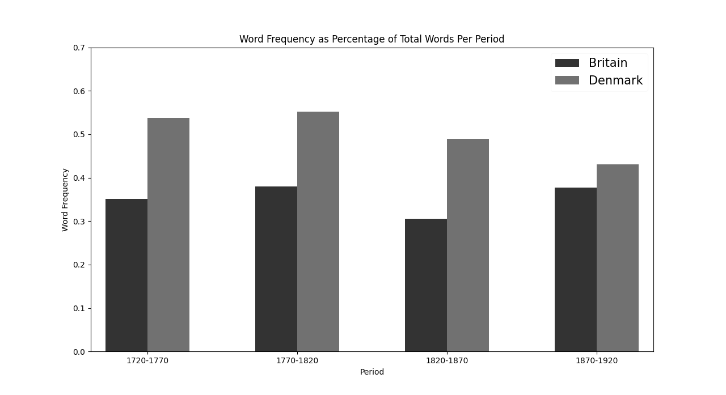
Environmental words include:
world earth forest wood mountain meadow glade grove river flora ocean sea wilderness pollution landscape
verden jorden skov træ bjerg eng lysning lund flod flora hav sø ødemark forurening landskab

FIGURE TWO: INDIVIDUALISM WORDS IN SNIPPETS OF TEXT SURROUNDING ENVIRONMENTAL WORDS IN BRITAIN AND DENMARK

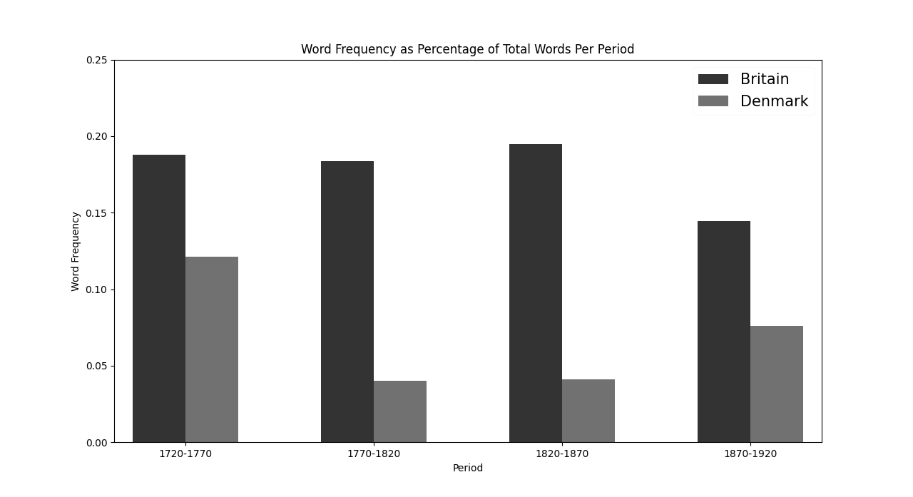
Individualism words include:

individual, independent, person, character, liberal, self

FIGURE THREE: SOCIETY WORDS IN SNIPPETS OF TEXT SURROUNDING ENVIRONMENTAL WORDS IN BRITAIN AND DENMARK

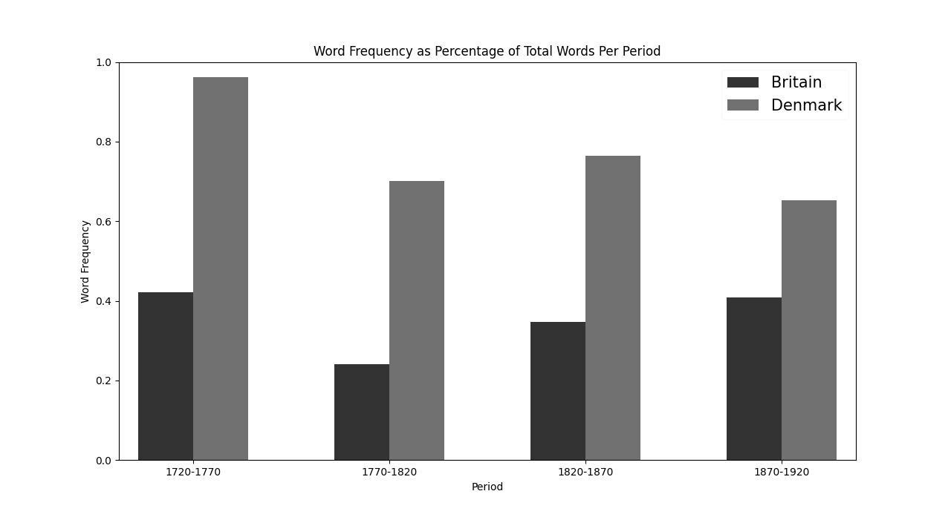
Society words include:
england/english/britain/countri/folk/peopl/collectiv/communal/custom/social/mutual
danmark/dannemark/dansk/land/folk/mennesk/kollektiv/fæl/skik/social/inbryd
FIGURE FOUR: MARKET WORDS IN SNIPPETS OF TEXT SURROUNDING ENVIRONMENTAL WORDS IN BRITAIN AND DENMARK

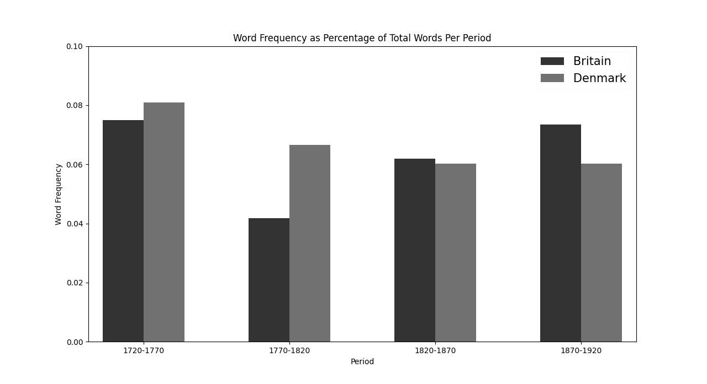
Market words include:
market/sell/buy/exchang/price/cost/trade/commerc
Marked/sælg/køb/udveksl/pris/kost/handl/handel

FIGURE FIVE: STATE WORDS IN SNIPPETS OF TEXT SURROUNDING ENVIRONMENTAL WORDS IN BRITAIN AND DENMARK
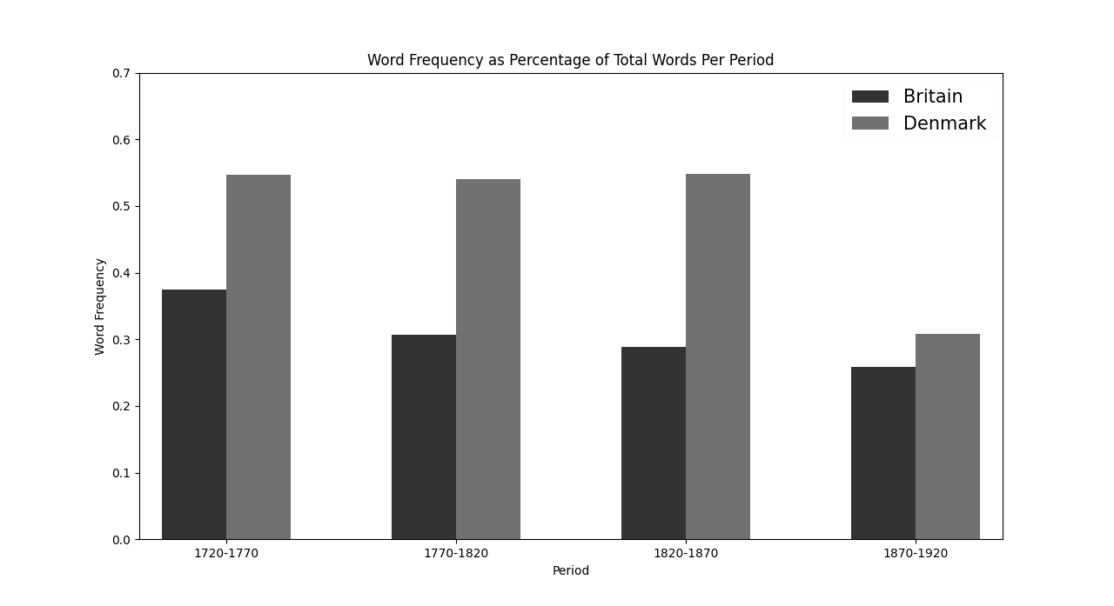

nation/govern/ministri/authority/law/legal/illeg/judgment/judg/council/commiss/committe/public/municip/parish/king/kingdom/crown/throne
stat/regering/ministeri/mynd/lov/gyld/ulov/vudering/dom/råd/kommission/uvalg/offent/kommun/sogn/kong/rig/kron/tron

FIGURE SIX: COOPERATION WORDS IN SNIPPETS OF TEXT SURROUNDING ENVIRONMENTAL WORDS IN BRITAIN AND DENMARK
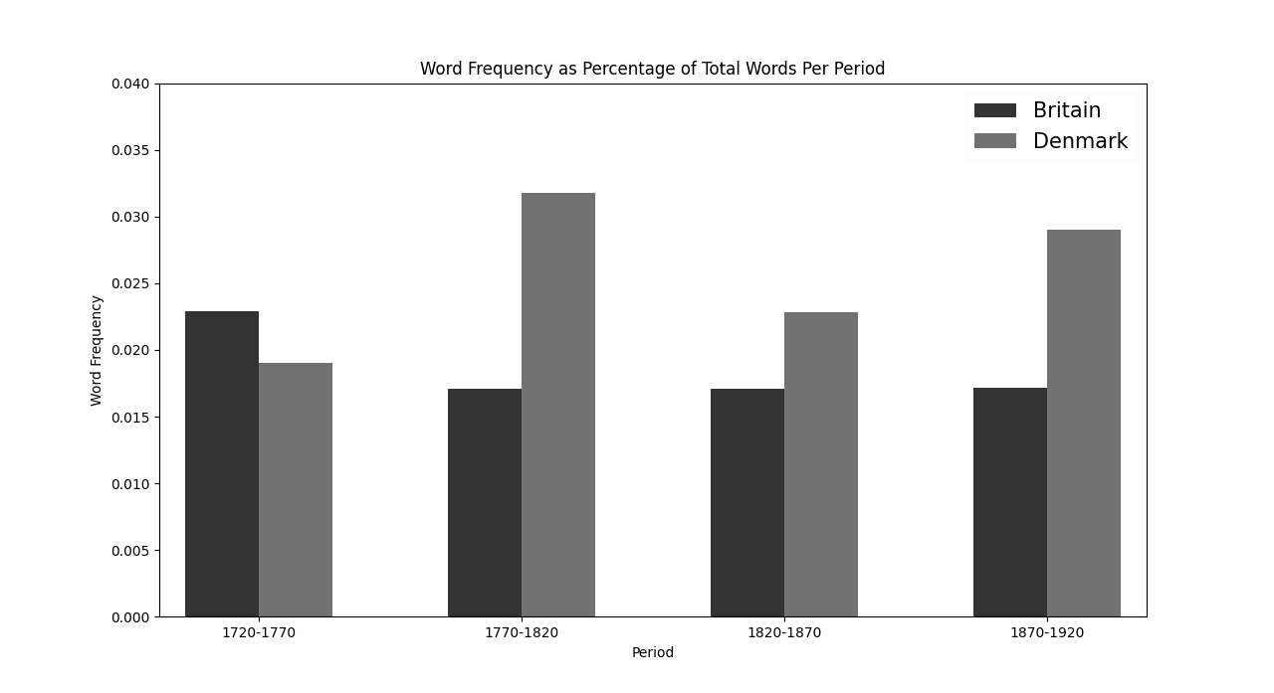
Cooperation words include:
Agreement/arbitr/bargaining/coalit/collabor/collectiv/compromis/cooper/coordin/negoti/pact/settlement/unanim/uniti/confeder/feder/union
aftal/voldgift/forhandling/koalition/samarbejd/fæl/krompromis/medvirkning/samordning/overenskomst/forlig/ordning/enstem/enhed/forbund/forening/fagforening

FIGURE SEVEN: REGULATION WORDS IN SNIPPETS OF TEXT SURROUNDING ENVIRONMENTAL WORDS IN BRITAIN AND DENMARK

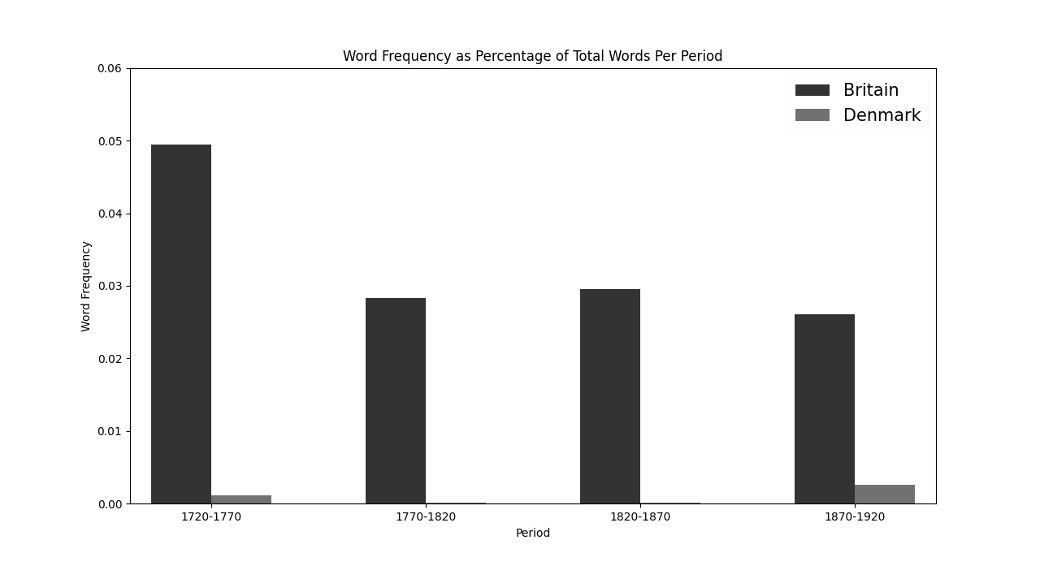
Regulation words include:
qualiti/regul/standard/assess/evalu/monitor/examin/inspection
kvalit/regulering/standard/vudering/evaluering/overvåg/eksam/inspection

Illusionen om en anden ædlere Virkelighed, end den vi ser, må der en Fjernhed og Fremmedhed, en sublim Overraskelse til for at gengive Jorden dens Friskhed.

